President
Julie Bruno
Sierra College

Vice President
John Stanskas
San Bernardino Valley College

Secretary
Dolores Davison
Foothill College

Treasurer
John Freitas
Los Angeles City College

Area A Representative
Ginni May
Sacramento City College

Area B Representative
Conan McKay
Mendocino College

Area C Representative
Rebecca Eikey
College of the Canyons

Area D Representative
Craig Rutan
Santiago Canyon College

North Representative
Cheryl Aschenbach
Lassen College

North Representative
Carrie Roberson
Butte College

South Representative
Randy Beach
Southwestern College

South Representative
Lorraine Slattery-Farrell
Mt. San Jacinto College

Representative at Large
Sam Foster
Fullerton College

Representative at Large
LaTonya Parker
Moreno Valley College

Julie Adams, Ph. D.
Executive Director

Subject: Hayward Award for “Excellence in Education”

The Academic Senate is pleased to announce the call for nominations for the Hayward Award for “Excellence in Education.” Sponsored annually by the Foundation for California Community Colleges, this award honors community college full-time and part-time faculty who demonstrate the highest level of commitment to their students, college, and profession. Award recipients, nominated by their college academic senate and selected by representatives of the Academic Senate must have a record of outstanding performance of professional activities, as well as, a record of active participation on campus.

Basic Information
- Each local senate can nominate one full- and part- time faculty member, however there can only be one honoree from each college.
- All faculty, classroom and non-classroom, are eligible for consideration.
- Previous nominees who did not receive the award may be re-nominated.
- Four recipients will be chosen and honored at the Board of Governors' meeting in Sacramento.
- Completed applications must be received in the Academic Senate Office by 5:00 p.m. on Friday, December 22, 2017.

Enclosed are the application and criteria. More information can be found on the Academic Senate website at http://asccc.org/events/hayward-award-0. Please note, that the applicant’s name or college cannot be listed in the application unless stated otherwise. Any applications that include the candidate’s name or college will be disqualified. A minimum of three nominations must be received for the selection process to proceed.

Please submit one original and one copy of your entire application via email or mail. FAX applications will not be accepted. Submit mail applications to: One Capitol Mall, Suite 340, Sacramento, CA 95814. Scanned applications must have the appropriate signatures and be emailed to awards@asccc.org. The Senate Office will notify you via email that your application has been received.

The selection process will be completed by February 5, 2018. Winners will be honored at the March 19, 2018 Board of Governors meeting in Sacramento. Please note, that the recipients of this award will be asked to submit a current photo. Although only four faculty recipients will be honored by the Board of Governors, we hope each college will honor its individual nominee.

Collegially,
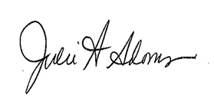
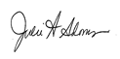
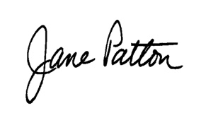
Julie Adams
Executive Director Enclosure (4)

