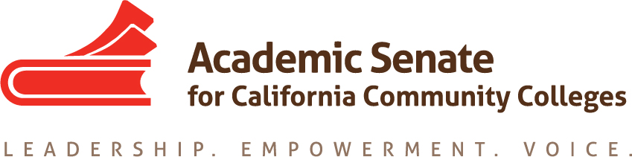

ASCCC Relations with Local Senates Committee (RwLS)

December 11, 2020

TIME 2-3:30pm

Attendees:

Stephanie Curry, Hossna Sadat Ahadi, Howard Eskew, Katherine Kroikowski

MINUTES

- Call to Order and Adoption of the Agenda

The meeting was called to order at 2:06pm and the agenda was approved by consensus

- Review Draft DEI Survey

The committee reviewed a draft DEI/Anti-Racism Survey to be sent to local Academic Senate Presidents in the Spring. Stephanie will address changes and re-send out draft. This will be agendized for the January 2021 ASCCC Executive Committee Meeting.

- Review Draft of Local Senate Visits Survey

The committee reviewed a draft Local Senate Visit Survey. Stephanie will ask that it be agendized for the January 2021 ASCCC Executive Committee Meeting.

- Rostrum Article (1.4.21)

Stephanie reminded the committee to add their information to the Rostrum Article by December 20, 2021.

- Future Agenda Items:
  - Review Committee Charge (Aligning with GP) (tag statement for each committee)
  - Equity Leadership Workshops/Canvas
  - Review of Draft Statewide Service Process Application
  - Review Draft Thank You Follow Up (Statewide Service)

- Announcements
  - Part Time Institute February 18-19, 2021
  - Spring Plenary April 15-17, 2021
  - Career and Non-Credit Institute April 30-May 2, 2021

- Adjournment

The committee adjourned at 3:04pm

