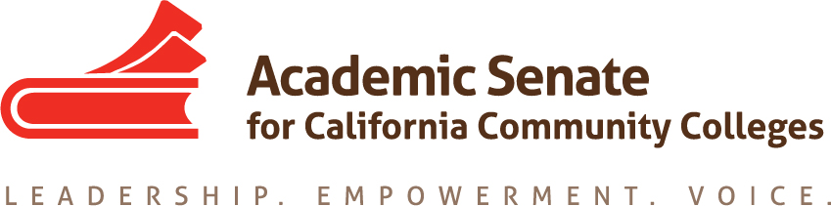

ASCCC Relations with Local Senates Committee (RwLS)

February 1, 2021

TIME 2-3:30pm

Attendees: Stephanie Curry, Robert L. Stewart Jr., Howard Eskew, Hossna Sadat Ahadi, Cheri Fortin, Nickawanna Shaw

MINUTES

- Call to Order and Adoption of the Agenda
The meeting was called to order at 2:04pm and the agenda was approved by consensus.

- Update on Surveys (DEI and Local Senate Visits)
Stephanie updated the group that the ASCCC Executive Committee approved the two surveys from this group 1) DEI survey 2) Local Senate Visits Survey. They will be used starting this spring.

- Review of Draft Statewide Service Process Application
The committee reviewed the draft of the proposed changes for the Statewide Service application process. These changes were based on committee discussions in Fall 2020. Stephanie will forward the recommendations to the ASCCC Executive Director

- Review Draft Thank You Follow Up (Statewide Service)
The Committee will review this and communication recommendations for those applying for Statewide Service at the next meeting.

- Planning for Equity Leadership Canvas Modules (Spring 2021)
The committee discussed the Equity Leadership Canvas Models. The committee will model these modules on those being done by the Guided Pathways Task Force. The will designed as short (10 Minute) Modules with a PPT and resources on the topics. Stephanie will set up Google Slides for the first three topics and folders to collect resources.

- DEI Liaison Description and Resolution
The ASCCC Executive Committee requested that the RwLS committee discuss and propose a description for a DEI Liaison. An Inclusion, Diversity, Equity and Anti-Racism (IDEA) Liaison resolution and job description was reviewed. Committee members had several concerns about the position including
1) The committee was concerned that this is the work of all and that some colleges would not take ownership of the work and put it all on the liaison
2) Concern that the most likely faculty members who would be named as liaison are our BIPOC faculty who are already vulnerable on our campuses and putting them in a position to have to be the IDEA champion might put extra stress on them
3) Other ASCCC Liaisons have funding (CTE, OER) and administrative/regulatory support and these liaisons would need similar support
4) That the ASCCC would need to actively engage these liaisons and not just make it a title.
Stephanie will share the document and the concerns with the ASCCC President and Executive Director

- Ideas for Rostrum Articles (Due 3.1.2021)
Nickawanna and Hossna will work on a Rostrum Article with a due date of March 1, 2021

- Future Agenda Items:
The committee reviewed the future agenda items
  - Review Committee Charge (Aligning with GP)
  - Equity Leadership Canvas

- Announcements—All events virtual for Spring 2021
Stephanie reminded the committee of upcoming ASCCC Events
  - Part Time Institute February 18-19, 2021
  - Spring Plenary April 15-17, 2021
  - Career and Non-Credit Institute April 30-May 2, 2021

- Adjournment
The committee adjourned at 3:18pm

