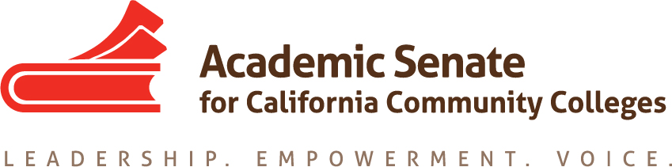

ACADEMIC SENATE FOR CALIFORNIA COMMUNITY COLLEGES
AREA A MEETING
Friday, March 24th, 2017
10:00 - 3:00
(Continental Breakfast at 9:30)
Building 700, Room 722
Chabot College
25555 Hesperian Blvd, Hayward, CA

- Welcome and Introductions

- Approval of the Fall 2016 Minutes
  - Fall, 2017 meeting - Location?
- Resolutions
  - Resolutions process overview –ASCCC Resolutions Committee
  - Review and discussion of pre-session resolutions
Development and discussion of any Area B resolutions
- Reports
  - ASCCC and Statewide Updates
    - Budget
    - Accreditation
  - Board of Governors Updates
  - ASCCC Foundation Report
- Lunch
- Reports From Colleges
- Announcements
Fall Plenary
Summer Institutes
Fall Regional meetings
- Adjournment – See you at plenary!

