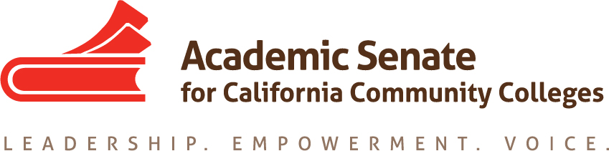

ACADEMIC SENATE FOR CALIFORNIA COMMUNITY COLLEGES
AREA C MEETING
Saturday, March 25, 2017
10:00 - 3:00
(Continental Breakfast at 9:30)

East Los Angeles College
Language Arts Building, E3-470
1301 Avenida Cesar Chavez
Monterey Park, CA 91754

- Welcome and Introductions

- Area C meeting for Fall 2017 – Moorpark College. Spring 2018?

- Reports (given during lunch)
  - ASCCC Update – Julie Bruno, President, ASCCC, John Stanskas, Vice President, ASCCC
    - Accreditation
    - Budget
    - Legislative Updates
    - Other issues
  - Academic Senate Foundation for CCC – Adrienne Foster, Secretary/Director
    - Foundation Update
    - Area Competition
    - Spring Fling at 2017 Plenary Session
  - Awards
  - Disciplines List (Adrienne Foster)
    - Overview of Disciplines List Revision Process
    - Submitted Proposals
  - Volunteering for Statewide Service

- Resolutions
  - Resolutions process overview – Rebecca Eikey, ASCCC Resolutions Committee
  - Review and discussion of pre-session resolutions
(Click “Resolutions” to download the resolutions packet and the appendices)
  - Development and discussion of Area D resolutions

- Reports From Colleges

- Announcements
  - Meetings/Institutes – Registration Now Open!

  - Upcoming Executive Committee Meetings
    - April 19, 2017, ASCCC Executive Committee Meeting, San Mateo Marriott
    - April 20-22, 2017, 2017 Spring Plenary Session, San Mateo Marriott
    - CTE Leadership Academy, May 5-6, 2017, San Jose Marriott
    - Faculty Leadership Institute, June 14-17, Sheraton Grand Hotel, Sacramento
    - Curriculum Institute, July 12-15, Riverside Convention Center

- Adjournment – See you at plenary!

