SUBJECT: EDAC Regionals |  | Month: September | Year: 2017
 |  | Item No: II. B.
 |  | Attachment: NO
DESIRED OUTCOME: | Executive Committee will review draft agenda for EDAC regionals | Urgent: NO
 |  | Time Requested:
CATEGORY: | Consent | TYPE OF BOARD CONSIDERATION:
REQUESTED BY: | Davison | Consent/Routine |  | X
 |  | First Reading
STAFF REVIEW: | Ashley Fisher | Action |  | X
 |  | Discussion
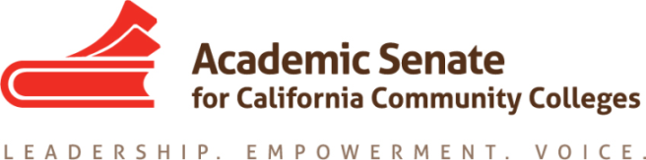
Executive Committee Agenda Item
Please note: Staff will complete the grey areas.
BACKGROUND:
EDAC is planning to hold regionals (north and south) centering around the topics of civil discourse and equity. The agenda (below) will be expanded upon following the EDAC meeting on Friday, 24 August.

Draft Proposals for EDAC Regionals – 27 and 28 October 2017
North Regional: Solano College
South Regional: Fullerton College
9:15-10:00 Registration/Continental Breakfast
10:00-10:15 Welcome; Introduction of Committee; Opening Remarks
10:15-11:45 Civil Discourse and the California Community Colleges (general session)
11:50-12:45 Lunch
12:50-1:35 Breakout session #1 – topics to be determined at EDAC meeting 24 Aug
1:40-2:25 Breakout session #2 -- topics to be determined at EDAC meeting 24 Aug
2:30 Dismissal

Staff will review your item and provide additional resources to inform the Executive Committee discussion.

