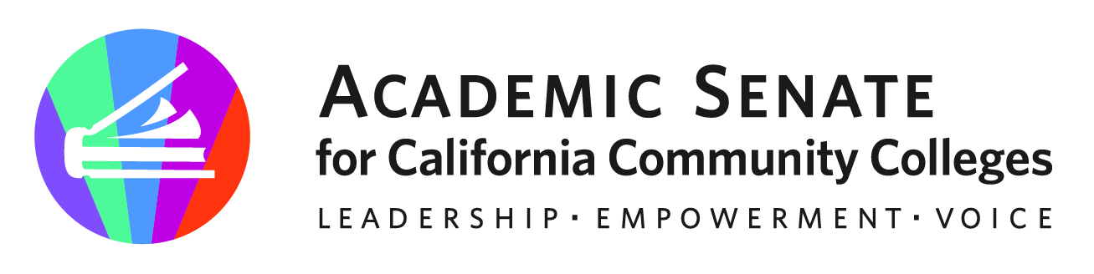
f

ASCCC CTE Leadership Committee

October 30, 2023

10-11am

Via Zoom

Meeting Summary

- Call to Order and Adoption of the Agenda – Meeting called to order at 10:01am, the chair welcomed all members to our meeting.

Stephanie Curry – Chair* | John Grounds | Marie Templo-Capule
Christopher Howerton – 2nd Chair* | Alexander Jones* | Sigrid Williams*
Amar Abbott* | Nicole Marquez*
Jimmie Bowen | Brian Palmiter* | Lynn Shaw*
Alana Gates* | Stephanie Rowe*

- Approval of September 25, 2023 Minutes - The committee affirmed the meeting summary. The chair will submit and post as appropriate.

- ASCCC and Regional Consortium – the chair updated the committee on the consortium regionals.
  - Debrief Continued - The SCC regional was covered by ASCCC Exec members LaTonya Parker, and Erik Reese. Each event was different, in formally and topics that were of focus. The chair, C. Howerton, and L. Shaw will be meeting with the regional consortiums this afternoon.
  - Planning for Future Events – The chair invited committee members to attend these events in their areas. Stephaie Rowe has offered to attend the NFN, and Alana Gates offered for LA & San Diego. Alex Jones is available for the Bay Area Regional, and Lynn Shaw is available for all. Sigrid Williams is happy to help for the Inland Empire on 2/9, and Amar Abbott is willing to attend Central/Motherload Regional.

- Webinar Planning -
  - CBE (December 7, 2023) – Southwestern and Coastline College representatives will be assisting with this online session. What is CBE and faculty roles and considerations for successful implementation.
  - Work Experience (February, 2024) – As a response with new regulations. Alex Jones expressed interest in supporting this event. The chair will reach out to some other groups. Alex shared a link to https://www.ciwea.org
  - Gender and CTE Fields (March 7, 2024 12-1:30pm) – Lynn and Nicole will work with others to help bring in these stories and experiences. Nicole and Lynn will sent to the chair a brief description for ASCCC. Style could be a webinar or as a “meeting”.

- Rostrum Brainstorming
  - January 9, 2024
  - March 3, 2024
  - Possible topics – CPL working with Sigrid; barriers of MQ for CTE faculty; Gender and CTE traditional CTE, Report out on the initial partnership with consortiums

- Future Meetings – A doodle poll will be sent to members to set next meeting.
  - November meeting to focus on spring work around MQs and Equivalency for CTE.

- Upcoming Events – The committee discussed the upcoming CPL summit and Sigrid provided some additional information about the event and some of the additional and exciting work that is happening in this area. The chair also reminded the committee about the upcoming ASCCC Fall Plenary. The committee also “brainstormed” some of the emerging CTE “hot topics” that would be good to include in the session. Suggestions included Chat GPT/AI; MQ for CTE and equivalency process for CTE. The committee shared several examples of challenges with equivalency process, and recruitment of CTE faculty. Focus on CPL, work experience regulation, budgeting, apprenticeships and opportunities with new grants/monies and how CTE faculty are included. Update on Career Education Masterplan updates to the field.

CPL Summit | November 3, 2023
Fall 2023 Plenary | November 16-18, 2023
Central/Motherload Regional Collaborative Event | February 2, 2023
Inland Empire Regional Collaborative Event | February 9, 2023
San Diego/Imperial | March 2, 2023
North Far North Regional Collaborative Event | March 27, 2023
Los Angeles Regional Collaborative Event | May 3, 2023
Bay Area Regional Collaborative Event | May 10, 2023

- Adjournment – The meeting adjourned at 10:56am

Status of Previous Action Items

- In Progress (include details about pending items such as resolutions, papers, Rostrums, etc.)
- Demystifying CBE Webinar (December 7, 2023)

- Completed (include a list of those items that have been completed as a way to build the end of year report).

- Orange Country Regional CTE Event -September 21, 2023- Orange Coast College
- South Central Coast Regional CTE Event- October 6, 2034 – Ventura Community College District Office

