President
Dolores Davison
Foothill College

Vice President
Virginia “Ginni” May
Sacramento City College

Secretary
Cheryl Aschenbach
Lassen College

Treasurer
Mayra Cruz
De Anza College

Area A Representative
Julie Oliver
Cosumnes River College

Area B Representative
Karen Chow
De Anza College

Area C Representative
Robert L Stewart Jr.
Los Angeles Southwest College

Area D Representative
LaTonya Parker
Moreno Valley College

North Representative
Carrie Roberson
Butte College

North Representative
Stephanie Curry
Reedley College

South Representative
Sam Foster
Fullerton College

South Representative
Manuel Vélez
San Diego Mesa College

Representative at Large
Silvester Henderson
Los Medanos College

Representative at Large
Michelle Bean
Rio Hondo College

Executive Director
Krystinne Mica

Subject: Hayward Award for “Excellence in Education”

The Academic Senate is pleased to announce the call for nominations for the Hayward Award for “Excellence in Education.” Sponsored annually by the Foundation for California Community Colleges, this award honors community college full-time and part-time faculty who demonstrate the highest level of commitment to their students, college, and profession. Award recipients, nominated by their college academic senate and selected by representatives of the Academic Senate must have a record of outstanding performance of professional activities, as well as a record of active participation on campus.

Basic Information
- Each local senate can nominate one full- and part- time faculty member; however there can only be one honoree from each college.
- All faculty, classroom and non-classroom, are eligible for consideration.
- Previous nominees who did not receive the award may be re-nominated.
- Four recipients (two full-time and two part-time faculty) will be chosen and honored at the Board of Governors meeting in March.
- Completed applications must be received in the Academic Senate Office by 5:00 p.m. on December 11, 2020.

Enclosed are the application and criteria. More information can be found on the Academic Senate website at http://asccc.org/events/hayward-award-0. Note: the candidate’s name or college cannot be listed in the application. Please submit a separate page with the candidate’s contact information. Any application that includes the candidate’s name or college may be subject to disqualification. A minimum of three nominations must be received for the selection process to proceed.

Please submit one original and one copy of your entire application by email ONLY. Scanned applications must have the appropriate signatures and be emailed to awards@asccc.org. The Senate Office will notify you via email that your application has been received.

The selection process will be completed by February 2021. Winners will be honored at the March 2020 Board of Governors meeting. Please note, that the recipients of this award will be asked to submit a current photo. Although only four faculty recipients will be honored by the Board of Governors, we hope each college will honor its individual nominee.

Collegially,
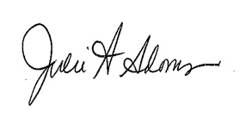

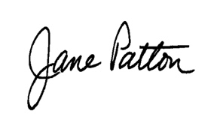
Krystinne Mica
Executive Director

Enclosure (4)

