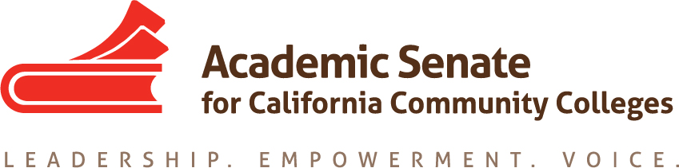

Accreditation and Assessment Committee

Monday October 24th, 2016

Members Present: S. Foster, L. Marchand, V. Martin, Z. O’Connor, C. Rutan, D. Wanner

Meeting called to order at 4:34 PM

- Approval of Minutes from 9/24/2016: Minutes from the September 24th meeting were approved by consensus. C. Rutan will post approved minutes to the ASCCC Website and send them in for inclusion in the late November Executive Committee meeting packet.

- Revised AAC Charge: The committee discussed the proposed changes to the committee charge, including changing the name of the committee to the Accreditation Committee. The revised charge was approved with minor edits provided by D. Wanner. C. Rutan will submit the revised charge to the Executive Committee for consideration.

- Update on ASCCC Executive Committee to NACIQI about ACCJC: The committee reviewed the letter to NACIQI about ACCJC that was approved by the Executive Committee at their October meeting. C. Rutan also reported that there is a resolution up for adoption at the Fall Plenary Session that would authorize ASCCC to send a representative (likely the ASCCC President) to the NACIQI hearing about ACCJC in February.

- Update CEO Accreditation Workgroups: The committee was provided an update on the continuing conversations between Workgroup I and ACCJC. The two continue to meet about once a month to address the recommendations submitted to ACCJC in the spring. The discussions have been described as positive, but the workgroup members are hoping to see more action from the commission. The most recent meeting included a discussion of new 18 month follow up report action that has been given to so many colleges in the last year. There will be a panel on Workgroups I and II during the Fall Plenary Session.

- Warren Bill on Accreditation and ACCJC Analysis: The committee reviewed the current language in the Warren Bill and the analysis provided by CRAC that was distributed by ACCJC. Committee members were asked to watch for updates on the legislation, but told that action was not expected until the new year. ACCJC has expressed concern that the bill, in its current form, would fundamentally change the regional accreditation process and shift to a more centralized federal model. A breakout on this topic may need to be added to the Accreditation Institute.

- Review of Draft Accreditation Institution Program: The committee was presented with the first draft of the Accreditation Institute program that was developed at the September 24th meeting. C. Rutan let the committee know that the Executive Committee would provide input on the draft program and may want to change the breakouts, general sessions, and/or the institute theme. If there are significant changes, the committee will have to adjust the program during the November meeting. The program with presenters and descriptions must be sent in by mid-December to be approved at the January Executive Committee meeting.
- ACCJC Participation at Accreditation Institute: The committee discussed whether inviting ACCJC to participate in the Accreditation Institute would be a good idea. The consensus was that the attendees would benefit from being able to ask questions of representatives from the commission and that they should be invited to participate. C. Rutan will share the committee’s thoughts with the Executive Committee while presenting the Accreditation Institute program.

Meeting was adjourned at 5:02 PM

Respectfully Submitted,

Craig Rutan

Approved December 14, 2016

