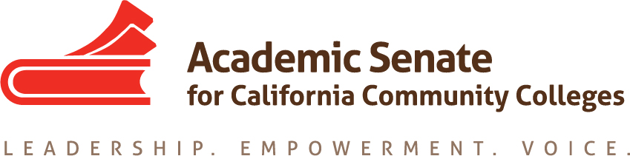

Accreditation Committee
February 13, 2018
4:00 pm – 5:00 pm
ConferZoom

PC, Mac, Linux, iOS or Android: https://cccconfer.zoom.us/j/235418728
Or Telephone:
Dial:
+1 646 876 9923 (US Toll)
+1 669 900 6833 (US Toll)
+1 408 638 0968 (US Toll)
Meeting ID: 235 418 728

MINUTES

Members Present: Ginni May, Irit Gat, Deborah Wulff, Misty Burruel, Christy Karau-Magnani

Members Absent: John Freitas

Guests: Steve Reynolds

- Select note taker – Ginni

- Approval of Agenda – done

- Approval of minutes from 1-22-2018 done by email

- Announcements – Ginni update the committee about status of presenters

- Accreditation Institute
  - Loose Ends
  - Double check the program
  - Dinner Thursday night – meet in lobby at 6:00 pm
  - Anything we missed – gift bags, Ginni will count the number of presenters

- Upcoming Events (http://asccc.org/calendar/list/events)
- Spring Plenary Session – Breakout on Accreditation, Ginni will check with Gohar and Stephanie to see if they are available Friday, April 13 at 2:15.

- Future Meetings
- April 10, 2018, 4:00 pm, ConferZoom
- Additional meetings TBD, if needed

- Adjourn – 4:33 pm

Status of Previous Action Items

- In Progress (include details about pending items such as resolutions, papers, Rostrums, etc.)

ASCCC Resolutions

S15 2.01 Disaggregation of Learning Outcomes Data
Research has been completed and presented at the ACCJC Conference in April 2017 and Spring 2017 Plenary Session. An annotated bibliography was provided to the Academic Senate and the ASCCC Foundation as part of the SLO Disaggregation project funded by the Foundation. 2017 - 18: Research was presented at the ACCJC 2017 Partners in Excellence Conference. Committee will hold off on I.B.6 until we hear back from ACCJC in January 2018. There could be a Rostrum to give an update on Disaggregation of Learning Outcomes Training, 2.01.

S15 2.02 ACCJC Written Reports to Colleges on Sanction
2017 - 18: The CCCCO Workgroups 1 and 2 have been involved in recommending many changes. An update will be presented at the Accreditation Institute.

F16 2.01 Local Recruitment and Nomination Processes for Accreditation Teams
2017 - 18: There will be a New Evaluator Training for Faculty at the Accreditation Institute Pre-session. In addition, a Rostrum article will be written to address the processes following the Accreditation Institute. Irit, Steve, and Ginni will write the article following the AI to submit March 5.

S17 9.01 Update to the Existing SLO Terminology Glossary and Creation of a Paper on Student Learning Outcomes
2017 - 18: The Chairs of the Curriculum and the Accreditation Committees are in the process of identifying committee members to serve on a task force to update the SLO Glossary and create a paper on Effective Practices for Student Learning Outcomes Assessment.

F17 2.01 Request Accrediting Commission for Community and Junior Colleges (ACCJC) to Readdress Bachelor’s Degree Program Requirements
On January 10, 2018 at the ACCJC Open Session meeting, G. May shared the ASCCC Resolution 2.01 Fall 2017 requesting that the ACCJC to consider modification of the ACCJC Policy on the Accreditation of Baccalaureate Degrees, June 2016 and readdress the minimum thresholds of upper division units for bachelor’s degree programs to reflect the variety of curricular designs required by different programs of study, and to be more consistent with the WSCUC standards. Following the open session one of the vice presidents shared that the ACCJC will reconsider this language after March 2018.

Strong Workforce Recommendations
Timeline | Goal | Current Positions | Action | ASCCC Committee Involvement |  | Comments
TBD | 9. a. Engage employers, workforce boards, economic development entities, and other workforce organizations with faculty in the program development and review process | 7.05 S14 Research Tools for Program Review; 13.02 F12 Redefinition of Student Success;  21.02 S12 CTE Program Review | Co-develop | CTE LC AAC Curriculum (EDAC) | High | 2017 - 18: Committees chairs to recommend to the president how to implement this recommendation. Resolution 21.02 S12 should be part of this conversation.
TBD | 9. b. Promote effective practices for program improvement (retooling) and program discontinuance based upon labor market data, student outcomes and input from students, faculty, college staff, employers, and workforce partners. |  | Develop | Ed Pol, AAC, and Curriculum | High | 2017 - 18: Ed. Policies to lead the conversation. Committee chairs to recommend to the president how to implement this recommendation. Chairs might consider exploring the development of a PDC Module using the ASCCC paper on program discontinuance. The Ed Pol might also be able to touch on some of recommendation in the upcoming on Educational Program Development.

Papers/Rostrums

- S17 9.01
- F16 2.01

- Completed (include a list of those items that have been completed as a way to build the end of year report).

