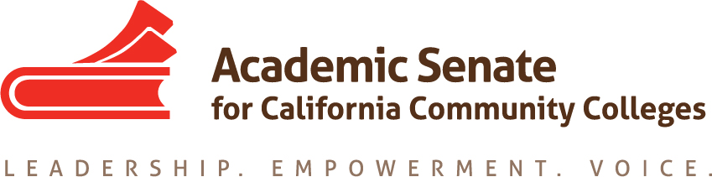

ASCCC Accreditation Committee

April 29, 2020

10:00-11:00pm

ZOOM

Phone one-tap: | US: +16699006833,,98187241932# or +13462487799,,98187241932#
Meeting URL: | https://cccconfer.zoom.us/j/98187241932
Meeting ID: | 981 8724 1932

AGENDA

- Call to Order and Adoption of the Agenda

- Selection of Minutes Taker and approval of last meetings minutes

- Wellness Check in

- 2020 Accreditation Institute debrief/ Review of survey

- Potential Rostrum Articles/Resolutions

- Committee roundup/ Recommendations for next years committee

- Adjournment

