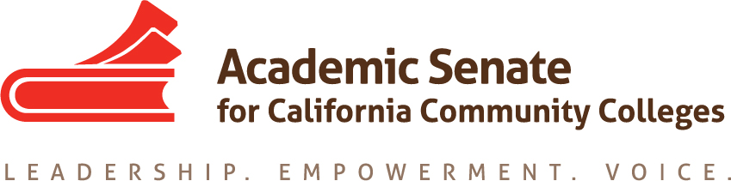

ASCCC Accreditation Committee

August 30, 2019

2:00-3:00p,

CONFERENCE CALL INFORMATION
Phone one-tap: | US: +16699006833,,237313301# or +16468769923,,237313301#
Meeting URL: | https://cccconfer.zoom.us/j/237313301
Dial: | US: +1 669 900 6833 or +1 646 876 9923
Meeting ID: | 237 313 301

AGENDA

- Call to Order and Adoption of the Agenda

- Selection of Minutes Taker

- Introduction of Committee members

- Action Items
  - Assigned Tasks
    - ASCCC Goal Governance Process and Faculty Role
    - ASCCC Accreditation Institute Theme
    - ASCCC Accreditation Institute Timeline
    - Review of past and potential strands and breakouts for ASCCC Accreditation Institute
    - Selection of in person meeting date

- Accreditation Institute Logistics (February 21-22, 2019)
  - Travel
  - Location: San Diego Marriott

- Potential Rostrum Articles

- Important Dates
  - Academic Academy (September 13-14, 2019)
  - Area Meetings October 11 and 12, 2019)
  - Fall Plenary Session (November 7-9, 2019)
  - 2020 Part Time Faculty Institute (January 24-25, 2020)
  - 2020 Accreditation Institute (February 21-22, 2020)

- Next Meeting Dates

- Adjournment

