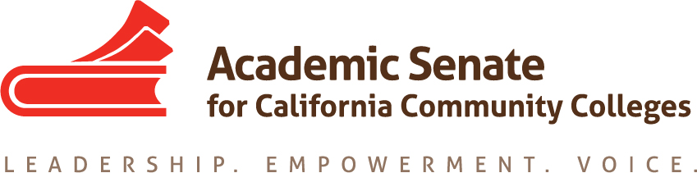

ASCCC Accreditation Committee

November 12, 2019

9:00am-11:00am

ZOOM

Minutes

Attendance: Stephanie Curry, Nathaniel Donahue, Elizabeth Romero, Ekaterina Fuchs, Ted Blake

- The meeting was called to order at 9:00 am and the committee and the agenda was adopted

- Stephanie Curry volunteered to take minutes

- Update on ASCCC Executive Committee review of and input on the initial draft agenda for 2020 Accreditation Institute

The committee reviewed the feedback from the Executive Committee including
- Make sure that all programs for each of the breakout groups have a variety of standards and not have multiple breakouts on the same standard in the same grouping.
- Suggestion to ask Sonya Christian to speak at a general session due to her expertise in Guided Pathways and Accreditation

- Action Items
  - Assigned Tasks
    - Address any Exec Committee changes or concerns
  - The committee reviewed the proposed schedule and felt that the breakout were evenly distributed across the standards
  - The committee agreed to have President Stanskas reach out to Sonya Christian, President of Bakersfield College about her availably for the Institute
    - Discuss General Sessions
      - The committee discussed the general sessions
    - Identify Institute Breakout Presenters
      - The committee discussed which breakouts they were assigned and brainstormed additional speakers. Stephanie Curry will send proposed speakers to John Stanskas for permission to invite speakers.
      - Stephanie will reach out to Stephanie Droker to get a list of speakers from the commission who would like to co-present.
    - Discuss Breakout Descriptions
      - Committee members agreed which breakout descriptions they will compose for draft #2

- Accreditation Institute Logistics (February 21-22, 2019)
  - Travel
  - Registration –Code for Registration
  - Location: San Diego Marriott—La Jolla

Stephanie reminded all committee members to register for the institute with the special code for committee members.

- Important Dates
  - 2020 Part Time Faculty Institute (January 24-25, 2020)
  - 2020 Accreditation Institute (February 21-22, 2020)

- Next Meeting Date

Stephanie will set up a doodle poll to schedule the next meeting after Exec has reviewed Draft #2

- Adjournment
The meeting adjourned at 9:37am

