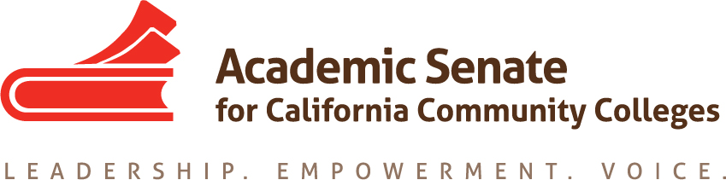

Equity and Diversity Action Committee
November 18, 2020
11:30 am-12:30 pm

ConferZoom

MINUTES

Members Present: LaTonya Parker (chair), Ginni May (2nd), Jamar London, LaTanga Hardy

- Call to Order at 12:02 pm

- Approval of Agenda: M/S/P – Ginni/Jamar

- Check-in: Committee members checked-in

- Action Minutes:
October 7, 2020: M/S/P – Jamar/Ginni
September 2, 2020: M/S/P – Jamar/LaTanga

- Committee Responsibilities: The committee chair informed the committee that keeping this information helps to remind us of our work.

- ASCCC Areas of Focus for 2020-21
- Guided Pathways Implementation and Integration to Transfer and Careers
- Culturally Responsive Student Services, Student Support, and Curriculum;
- Equity Driven Systems

- From the Chancellor’s Office Diversity, Equity, and Inclusion (DEI) Workgroup:
- ASCCC, HR, and local union to review existing evaluation procedures. (Tier 1)*
- ASCCC, HR, and local union to create a process where conversations about cultural competencies can happen outside the evaluation process. (Tier 1)*

*Tier 1 and Tier 2 activities are strategies that involve policy changes, changes to existing procedures, and or activities that promote supportive and inclusive behaviors. Aligned to the Vision for Success commitments, Tier 1 activities can be achieved in a 6-12 months’ timeline (CCCCO Call for Action June 2020)

The committee continued discussion from October meeting on responding to the DEI recommendations:
- Ways to examine and modify review processes, procedures, and structures.
- Topics around accountability, explicit training, measurable outcomes, onboarding, eradicating systemic injustices, creating equity minded syllabi, inquire/interrogate/integrate, mentoring, and clarity about what faculty are being assessed on.
- ASCCC, HR, and local union to review existing evaluation procedures.
  - Discussion Item - Recommendations:
  - Webinars – discipline specific near spring FLEX days for faculty professional development
- LaTanga Hardy – ECE and DEI Education one-hour webinar in mid-January
- Jamar London – STEM and DEI Education one-hour webinar in mid-February, Sam Foster, Janet Fulks, Peggy Campo
- one-hour webinar in mid-March
  - EDAC and GPTF Recommendations
Webinar Ideas – webinar suggestion #2 from above, and possibly #3
  - Mentor program – Recommendation to the FELA

- Regional Meetings – Updates regarding partnerships with ASCCC Guided Pathways Task Force. Ginni shared some of the recommendations provided to the ASCCC Executive Committee during the November meeting. No action was taken by the Executive Committee. However, each of the Standing Committees were encouraged to examine the recommendations, consider modifications that could be made to their charges to incorporate the work of Guided Pathways and report back to the ASCCC Executive Committee.

- Rostrum Article(s) – articles for consideration are due in January. Bring ideas to the November meeting. One idea shared was “Getting to the why”.

- Resolutions

The committee chair shared some of the passed resolutions during the 2020 Fall Plenary Session: https://www.asccc.org/resources/resolutions
03.01 | 2020 | Fall | Support The Anti-Racism Pledge | Diversity and Equity
03.02 | 2020 | Fall | Recommendation to Update Title 5 Language for Section 53022 | Diversity and Equity
03.03 | 2020 | Fall | Adopt Anti-Racism Education Paper | Diversity and Equity
03.04 | 2020 | Fall | Develop Resources on Effective Practices for Anti-Racist, Equitable, and Inclusive Instructional Strategies | Diversity and Equity
It should be noted that these resolutions will be assigned to a committee, several committees, individuals, or other groups by the ASCCC President and Executive Director and then confirmed by the Executive Committee during the December 2020 Executive Committee meeting.

- Action Item: Tier 1 Recommendations

  - ASCCC, HR, and local union to review existing evaluation procedures.
  - ASCCC, HR, and local union to create a process where conversations about cultural competencies can happen outside the evaluation process.

- Resources:
Resource 1—Equity and Diversity Action Committee Resolutions Report Dec 2019 Revisions
Resource 2— THE ACADEMIC SENATE FOR CALIFORNIA COMMUNITY COLLEGE ADOPTED FALL 2019 EQUITY-DRIVEN SYSTEMS Student Equity and Achievement in the California Community Colleges
Resource 3— Summer 2020 ASCCC Rostrum
Resource 4—II. E. (1) EDAC Charge, ASCCC Inclusivity Statement Revise.pdf
Resource 5—II. E. (2) EDAC ACTION PLAN draft.pdf
Resource 6— https://www.asccc.org/directory/equity-and-diversity-action-committee

- Final Fall 2020 Committee Meeting:
Wednesday, December 2, 2020 11:00-2:00 – this meeting time was extended.

- Forms (when travel resumes):
ASCCC Flight and Travel Request Link
ASCCC 2020 Expense Reimbursement Form

- Upcoming Events – https://www.asccc.org/calendar/list/events

- Announcements
College Visit – Santa Rosa Junior College
Friday, November 13, 2020 LaTonya Parker Ed. D. and Stephanie Curry

- Adjourned Meeting at 12:34 pm

