ASCCC Foundation Presidents Report

Area Meetings 2021

- Current Directors: Stephanie Curry (President), Manuel Velez (Treasurer), Michelle Bean (Secretary), Karen Chow and Krystinne Mica, Van Rider
- Directors approved four, in-person scholarships (one from each area) for the Fall 2021 Plenary and 13 online scholarships

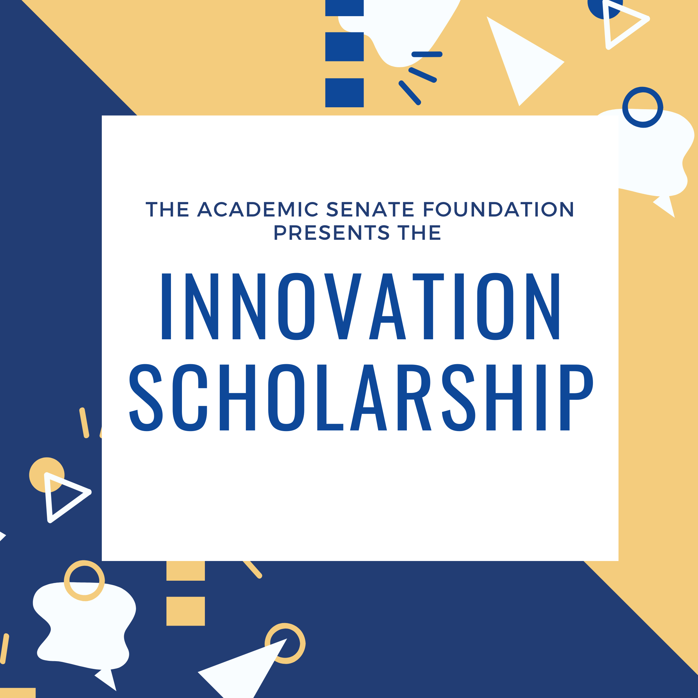
- Innovation Scholarships provide faculty with funding to attend ASCCC events as well as external events and conferences to expand their understanding of best practices and apply them to their local college and share those results with the field at large.

- Faculty can support fellow faculty by donating to the ASCCC Foundation. Easy ways to donate are through 1) Selecting the ASCCC Foundation through Amazon Smile 2) Contribute through the Foundation Website https://asfccc.com/get-involved/
3) Contribute during Giving Tuesday (November 30, 2021)

