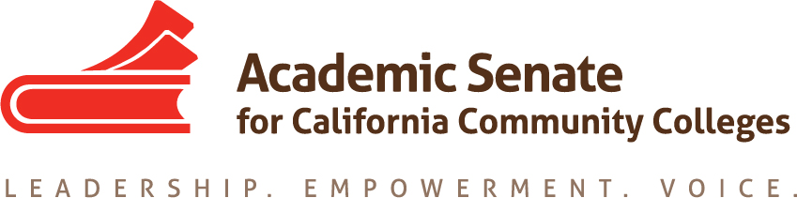

Online Education Committee
Zoom meeting
Friday, August 31, 2018
8:00am – 9:00am

MINUTES

In attendance: Anna Bruzzese, Geoffrey Dyer, Leticia Hector, Cathy Hernandez, Michael Heumann, Julie Oliver

- Selection of Note Taker
Anna Bruzzese volunteered to take notes.

- Welcome and Introductions
Geoffrey Dyer welcomed the committee members and everyone introduced themselves.

- Scheduling of Future Meetings
The next meeting will be online, on Wednesday, September 12 at 8 am.

- Review the Committee Charge and Responsibilities
The committee reviewed our charge and responsibilities (copied below) and agreed that there are no changes needed at this time.

  - The Online Education Committee informs and makes recommendations to the Academic Senate Executive Committee and the faculty regarding policies and practices in online education and educational technology. The Committee supports quality online education and the effective use of educational technology by researching issues, writing background and position papers, and making presentations at plenary sessions and other
events as needed. When appropriate, the Committee interacts with Senate standing committees advocates for policies, and proposes resolutions.

- Committee Priorities
The committee discussed the following priorities and agreed that items “c” and “d” should have higher priority than items “a” and “b”. The committee agreed that we would like to have some kind of finished product related to items “c” and “d” by the Spring 2019 Plenary. That may mean a breakout session or a Rostrum article.

The committee also discussed how to best approach items ‘a” and “b” in terms of collecting relevant data. Suggestions included surveys, reaching out to faculty with the expertise in the area, breakout sessions.
  - 11.01 S17 Using Savings from Adopting Canvas
  - 9.02 F17 Expand System-wide Online Educational Opportunities
  - 9.03 S18 Effective Practices in Online Communication Courses
  - 9.04 S18 Effective Practices in Online Lab Science Courses

- Relevant Issues
  - Ensuring an Effective Online Program: A Faculty Perspective adopted at Spring Plenary
Geoffrey briefly discussed the paper and recommended that committee members read it.
  - Changes to Title 5 §§55200-55210
The Board of Governors had a first reading of the proposed changes in the summer and will have a second reading in September. The expectation is that these changes will be approved.
  - Status of Fully Online College
The Board of Governors is to be the California Online Community College’s initial Board. Three programs are to be developed by July 2019 (Manufacturing, Child Development and Health Services) and this college is to start enrolling students by the last quarter of 2019. There was a suggestion from ASCCC President John Stanskas that the committee should consider writing a resolution that the ASCCC act as a senate for this 115th fully online college until they have faculty and can form their own senate. The committee agreed to work on the draft resolution over email. Geoffrey volunteered to be the lead.
  - CVC-OEI: Expanded Consortium, Rebranding, Move toward Local Review
A goal within the CVC-OEI Five-Year Roadmap is that within five years, all California community colleges will be a part of OEI. Foothill De Anza College was awarded a grant to lead the new phase of the effort. There was a request from an ASCCC OEI Liaison that the committee consider developing a resolution regarding encouraging colleges to adopt the OEI rubric for their local review of online courses. The committee agreed to invite Cheryl Achenbach who has been involved in this work on behalf of the ASCCC to our next meeting for additional feedback.

- Fall Plenary Planning: November 1-3, Irvine Marriott
  - Suggested Breakout Topics Submitted: CVC-OEI, Effective & Promising Online Practices, The Fully Online College, Hot Topics in Online Education
Geoffrey was asked to submit some items for the Fall Plenary to the ASCCC Exec, and he has submitted the breakout topics listed in item VII a.
  - Potential Resolutions Regarding Online Education
The committee has discussed some potential resolutions under items V, as well as VI c and VI d.
- Announcements
  - Academic Academy—September 14-15, San Francisco
  - Area Meetings—October 12 and 13, Various Locations
  - Fall Plenary—November 1-3, Irvine

The committee meeting adjourned at 9:08 am.

