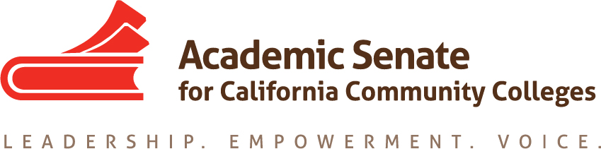

ASCCC Relations with Local Senates Committee (RwLS)

September 25, 2020

TIME 2-3:30pm

Attendees: Stephanie Curry, Howard Eskew, Katie Krolikowski, Hossna Sadat Ahadi, Nickawanna Shaw

Not able to Attend: Robert L. Stewart Jr., Cheri Fortin

MINUTES

- Call to Order and Adoption of the Agenda
The committee was called to order at 2:01pm. The committee approved the agenda by consensus.
- Action Items
  - Assigned Resolutions
The committee reviewed the assigned resolutions and decided to prioritize the DEI Recommendations
    - 19.01 F18 Encourage Dialog about Equivalency Practices
    - 19.02 S18 Defining Collegiality in the Workplace
    - 17.02 S18 Increase Participatory Governance on College Satellite Campuses
  - Assigned Tasks
The committee reviewed the DEI Recommendations and reviewed the proposed ideas from the EDAC Committee. EDAC recommendations focused on the first recommendation on recruitment strategies. RwLS focused their discussion on the second DEI recommendations regarding professional development. The committee discussed having a joint meeting with EDAC to map out the response on the DEI Recommendations. Stephanie will contact LaTonya Parker EDAC Chair.
    - DEI Recommendations
      - Develop Culturally Responsive Faculty and staff (classified and Administrators) recruitment strategies
      - Design Professional Development workshops to increase knowledge and understanding of cultural competency and diversity
The committee brainstormed ideas for professional development ideas for a web series and potential plenary topics for Spring 2020
    - Resources on Website under RwLS https://asccc.org/communities/local-senates
The committee discussed coming up with a Top 10 documents for Senate Presidents to be added to the Website under the RwLS Committee page.
Items such as: PCAH, 10+1, Minimum Qualifications, Area Maps, ASCCC Handbook, Resolutions Handbook, Brown Act Information, Board Policies Document, Information on Tech Visits
The Committee also discussed the wish for a 10+1 Infographic for the website.

    - Review/Revise Process for ASCCC Statewide Service Applications
This item will be moved to the next agenda
    - Local Senate Connections
      - Review of Email Language
The Committee reviewed the language used for outreach last year. The committee discussed adding context of the COVID Crisis and suggested examples of support services offered by the ASCCC.
      - Assigning Colleges to Committee Members
The Committee divided the colleges by area and assigned committee members. The members will contact the colleges once the email language is finalized and approved. Responses from colleges will be noted on the spreadsheet in the RwLS Google Drive.

- Rostrum Articles
The Committee reviewed ideas for possible Rostrum Articles for the November deadline including one on the Hiring Tools and Senate Succession Planning (one- and two-year term presidents).

- Announcements
The committee reviewed the upcoming ASCCC Events
  - Academic Academy- October 8, 2020
  - Fall Plenary November 5, 2020

- Adjournment
The committee adjourned at 3:14pm

