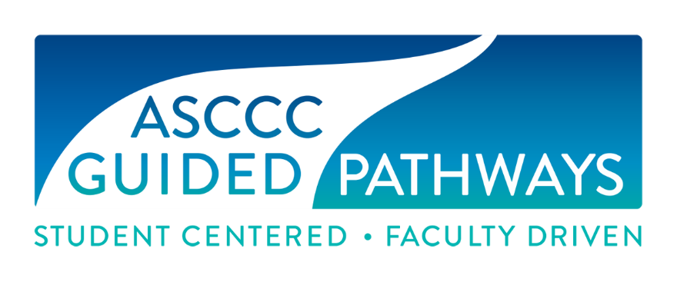

Guided Pathways Task Force Meeting
MINUTES
Thursday, January 30, 2020
11:00 a.m. – 4:00 p.m.
San Bernardino Valley College

In Attendance
Julie Bruno, Communications Faculty, Sierra College, ASCCC Past-President
Mayra Cruz, ASCCC Area B Representative
Janet Fulks, ASCCC Guided Pathways Faculty Lead
Jeffrey Hernandez, ASCCC Guided Pathways Faculty Lead
Virginia May, Chair, Guided Pathways Taskforce
Dana Miho, ESL Faculty, Mt. San Antonio College
Meridith Selden, Yuba Community College, Psychology Faculty
Ty Simpson, ASCCC Guided Pathways Faculty Lead
Eric Thompson, Humanities Faculty, Santa Rosa Community College
Eric Wada, C-ID Co-Curriculum Director

ASCCC Staff
Krystinne Mica, ASCCC Executive Director
Miguel Rother, ASCCC Director of Grants and Initiatives

Attendance via Zoom
Jessica Alabi, ASCCC Guided Pathways Faculty Lead, Orange Coast College
Jennifer Valencia, ASCCC Program Manager

Action | Consent Calendar  Approval of November 26, 2019 Meeting Minutes  Committee member introductions
Discussion | Chair’s Report (May)  New members representing noncredit instruction, and partnership with the curriculum committee to address noncredit and GP resolution. GSP and onboarding tools available on Canvas. ASCCC giving input to CCCCO on Pathways to Equity conference.
Discussion/  Action | Committee Priorities – Resolutions (May)  S18 17.01 Noncredit Instruction in Guided Pathways Efforts  Presentation proposals sent to Career and Noncredit Education Institute, and potentially to the Curriculum Institute. There is a Spring Plenary breakout assigned to the Noncredit Committee chair. Rostrum articles and webinars to share information to the field.  F19 3.01 Assessing Student Equity and Achievement Program Contribution to Guided Pathways Implementation  - Further guidance will be sought on the first resolved statement – Ginni and Krystinne will discuss.  - Jeffrey and Ty will provide ideas for how to address the second resolved statement.  F19 9.01 Local Determination of International Baccalaureate Credit at California Community Colleges  - Assigned to GPTF, Curriculum Committee, and Noncredit Committee: GPTF will request guidance from the Curriculum Committee – Ginni will contact Cheryl  F19 13.01 Collegial Consultation during Implementation of Guided Pathways  Regional workshops and regional meetings were used to address this.  - A survey will be designed by Jeffrey and Mayra. Include discussions about equity as an academic senate concern as it falls under the 10+1.
Discussion/  Action | Spring Plenary Session  - Breakouts: Discussion regarding plenary sessions and GPTF members interested in presenting. Titles and descriptions are due March 6th. The First two names were assigned by the ASCCC President – the 3rd name are suggestions from the GPTF  - 2:15 p.m. to 3:30 p.m. SECOND BREAKOUT SESSION  Assessment of College Placement Processes: Successes and Areas for Improvement (Ginni May, Stephanie Curry, Janet Fulks)  - 3:45 p.m. to 5:00 p.m. THIRD BREAKOUT SESSION  Program Review: Equity Driven and Connected to Guided Pathways (Ginni May, Janet Fulks, Eric Thompson)  - 2:15 p.m. to 3:30 p.m. FOURTH BREAKOUT SESSION  Guided Pathways, Transfer Degrees, College Catalogs and Curriculum: Difficult Conversations about putting students first (Ginni May, Julie Bruno, Eric Wada)  - 3:45 p.m. to 5:00 p.m. FIFTH BREAKOUT SESSION  Report on Resolution S19 5.02 Guided Pathways Budget Development (Nathaniel Donahue, Janet Fulks, Jeffrey Hernandez) – A Rostrum article to address this resolution is being drafted by Jeffrey, Julie, and Ginni and is due March 9.  - Resolutions: Discussions about potential resolutions for Spring Plenary.
Information | GPTF Teams (May)  Some changes to team membership have occurred. Canvas website will be reorganized. Former GP presentations uploaded to Basecamp.  - Next meeting: discuss where tools are published.
Discussion | Guided Pathways Workshops Preparation (All)  Overall scope of the workshops planned today, group leads will plan the content of each, presenters assigned for each day. GPTF members invited to attend and help. The overall program was planned. Group leads will come up with a list of materials needed in advance.  - Descriptions of each presentation du by February 10th.  Schedule:  10:00-10:10 Opening remarks and Welcome  10:10-10:45 Strengthening Local Implementation with Guided Pathways Liaison  10:45-12:00 Data  12:00-12:30 Lunch  12:30-1:30 Data  1:30-1:40 Break  1:40-2:50 Defining Roles of Counseling faculty, paraprofessionals, faculty advisors  2:50-3:00 Closing Remarks
Discussion/ Action | Webinar Field Contributions (Fulks)  Topics of previous webinars included governance, including student voice. Future webinars: ongoing concerns related to AB705 including course offerings and impacts on other disciplines, equity gaps when assessing AB705 innovations, Scale of Adoption Assessment: how it can be helpful to colleges and debunking myths about its use. Noncredit instruction in GP including English and Math CDCP noncredit pathways to credit (how to, pros/cons).
Discussion | Site Visits (Thompson)  Discussion related to the scope of ASCCC visits, and GPTF members are encouraged to participate as they are able.
Discussion | Equity Assessment (Cruz)  Proposal to collaborate with EDAC to develop an Equity Assessment tool. Develop a tool that can help colleges evaluate how they are assessing equity implications of AB705 implementation. This tool will not be a “one-size fits all” approach, but rather a repository of questions and recommendations for qualitative and quantitative data collection to assess how colleges are meeting the needs to of their local student populations as they continue to refine their AB705 implementation strategies.  - Need a lead from the GPTF and a few team members
Discussion | Future Agenda Items  - Further discussion on how to evaluate AB705 implementation – Ginni will get this rolling.  - Evaluating student-centered scheduling

