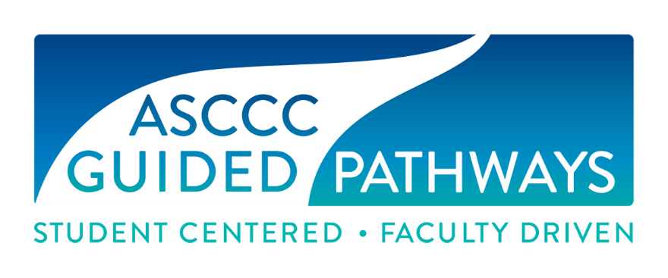

Guided Pathways Task Force
Minutes
May 15, 2020

Present: Ginni May, Krystinne Mica, Julie Bruno, Ty Simpson, Janet Fulks, Mayra Cruz, Jessica Ayo Alabi, Jeffrey Hernandez, Nate Donahue, Eric Wada, Eric Thompson, Miguel Rother, Selena Silva, Jennifer Valencia

Minutes taken by Julie Bruno

- Minutes approved

- Check in and Announcements
Professional development in April recap

- Reports
Executive Director Report – No GPAC until June. Ginni and KM trying to meet with Marty. Last meeting discussed with Marty ASCCC plans. Major focus for KM was budget. Reduction of 25%, which is a significant amount. ASCCC will work with legislature to see if reduction can be reduced or eliminated. Working with Marty to see if ASCCC can have money for GP in future. Question on GP funds overall and how it will impact CO work like the Regional Coordinators. Hopefully, more answers will be forthcoming.

Chair Report – Ginni reviewed report sent out earlier. Question on GPAC issues. Ginni sent these for inclusion into June agenda. Question regarding EDAC work and integrating into second goals area. Yes, one of the “to do” for next year is placement of English and Math and equity impacts.

Canvas Report – Eric and Meridith discussed that some work is delayed but on target for June 1. All agreed that the work in progress looks good.

Webinars – Jessica provided an update on the webinars with proposals for upcoming webinar topics. Will we move to do webinars in the summer?

Presentations – Minimal report since the presentations are done by other teams.

Tools – Janet presented the report on tools for this year. Going forward we don’t need a tools team but someone needs to monitor and make sure it gets to be where it needs to be for folks to get access.

Liaisons – Jeffrey presented a report on supporting the liaisons. Discussed use of coffee hour for liaisons and how well it worked. Suggestion to keep doing these in fall. Break into regions to be able to manage the conversation a little bit more. This would increase connection and networking with liaisons.

Tech visits – List of teams and visits. Two were virtual and they turned out well.

- White paper – Ginni and Janet shared a brief outline of the white paper as well as the introduction and conclusion drafts. The hope is to have something for the GPTF to read at the end of next week.

Covid 19 status – Ginni provided and update.
Action: Move forward with student paper with SSCCC; Ty and KM taking the lead; others will serve to provide feedback and edits. The faculty paper will be put on hold for now.
Moved: Jeffrey
Second: Eric W
Approved

- Professional Development Webinar Series – Janet provided an update with numbers on attendance. Suggestion: Senate examine what was effective and where we need to improve. Specifically, for GP – 10 different GP pathways webinars, appx 700 in attendance; about 1600 attendees over the year. We need to evaluate if attending webinars helps attendees to get traction on GP on their local efforts.

- Survey – Jeffrey and Mayra shared results of the Collegial Consultation survey. The results can guide future topics for webinars and PD. There are specific topics for GP liaisons and coffee hour.

- Statewide service – GM and KM provided information.

Meeting adjourned at 1:01pm

