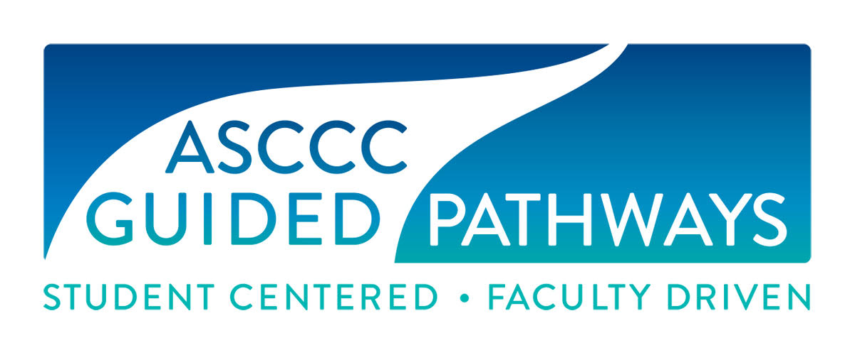
Guided Pathways Task Force (GPTF)
Wednesday, September 4, 2019
8:00 a.m. – 9:00 a.m.

In Attendance

Jessica Ayo Alabi, ASCCC Guided Pathways Faculty Lead, Orange Coast College
Mayra Cruz, ASCCC Area B Representative
Nate Donahue, ASCCC At-Large Representative, Santa Monica College
Janet Fulks, ASCCC Guided Pathways Faculty Lead
Jeffrey Hernandez, ASCCC Guided Pathways Faculty Lead
Virginia May, Chair, ASCCC Guided Pathways Taskforce
Meridith Seldon, Yuba Community College, Psychology Faculty
Ty Simpson, ASCCC Guided Pathways Faculty Lead
Eric Wada, C-ID Co-Curriculum Director

ASCCC Staff
Krystinne Mica, ASCCC Executive Director
Miguel Rother, ASCCC Director of Grants and Initiatives
Jennifer Valencia, ASCCC Program Manager

- Introduction and Announcements
Chair May called the meeting to order at 8:00 a.m.

- Approval of Agenda
Agenda was approved by consensus.

- Rostrum Article Update
May reviewed articles and topic assignments. May the provided feedback for the process of writing Rostrums. May reviewed rostrum article assignments.
Rostrum Topic | Article Assignments
The State of Meta-Majors in the CCCs | Fulks and Donahue
Governance in Guided Pathways | May and Thompson
Counseling and AS Representation in Guided Pathways | Simpson and Hernandez
Student Engagement in Guided Pathways | Alabi and Cruz

Follow Up: Rostrum articles are to be submitted to May on September 26th, 2019 for review.

- Resolutions
May introduced two resolutions for group discussion.
A. Resolution - Collegial Consultation During Implementation of GP
This resolution will conduct a survey to ascertain and evaluate if and how collegial consultation has been used to implement the areas of guided pathways that fall within academic and professional matters. The results of the survey will be used to create professional development training on Governance and Guided Pathways implementation.
B. Resolution - Assessing Student Equity and Achievement in GP
This resolution encourages local senates to participate in the annual report on Student Equity and Achievement Program (SEAP) and the assessment of how SEAP funded activities contribute to local Guided Pathways implementation.

The group reviewed the resolutions, discussed the areas and challenges that the resolutions will address, and suggestions were made for edits. GP Members discussed developing connections between faculty, the CCCCO and the ASCCC in order to broaden the reach and increase the resources of the GP Taskforce. Members shared their concerns for students’ success and equity as some programs are not properly targeting or benefiting underserved students.

Follow up: Minor edits will be made before May moves forward with the resolutions.

- Team Lead Reports
A. Webinars
Ayo Alabi provided schedule, topics, and descriptions of upcoming GP webinars. GP webinars will be held every second and fourth Wednesday of the month. Team planning meetings are scheduled for the first and third Wednesday of the month. The schedule for the GP webinars was posted on Basecamp to provide members with personal access.
B. GP Liaisons
Hernandez drafted a letter to GP Liaisons for May to review. May then suggested to send out a survey to GP Liaisons to obtain responses in October to schedule regional meetings for spring 2020.
C. Technical Visits
The group discussed dates and locations for the upcoming regional meetings. A suggestion was made to create a general presentation that can be used for all of the meetings but still tailored to address local needs.
Regional meeting dates:
North | South
October 24, 2019 | October 25, 2019
November 1, 2019 | November 1, 2019

Follow up: May will work with the group regarding facilitators for the regional meetings once locations are confirmed.
V. Future Agenda Items and Follow-up
A doodle poll will be sent to identify a date/time for a Zoom meeting. Future GP Task Force meetings dates and times will be discussed during the October 1, 2019 in-person meeting.

Meeting called to an end at 9:00 a.m.
Respectfully submitted by:
Jennifer Valencia, ASCCC Program Manager

