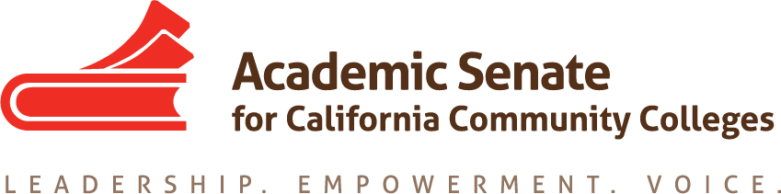

Accreditation Committee Meeting

6 November 2018, 10:00-11:00 a.m.

Zoom Teleconference Information

Join from PC, Mac, Linux, iOS or Android: https://cccconfer.zoom.us/j/5462550600

Or iPhone one-tap (US Toll): +14086380968,5462550600# or +16465588656,5462550600

Dial: +1 408 638 0968 (US Toll) or +1 646 558 8656 (US Toll)

Meeting ID: 546 255 0600

Minutes

- Call to Order and Adoption of the Agenda
  - Approved
  - Members present: Sam Foster (chair); Dolores Davison, Christopher Howerton, Celia Huston, Margarita Pilado, Colin Williams, Steve Reynolds (ACCJC Liason)
  - Note Taker: Colin Williams

- Review of Minutes from October 30 Meeting
  - Minutes Approved

- Review Outline of Accreditation Paper with Assigned Topics (attached)
  - Members agreed that sections would be completed and sent to margarita on January 8, 2019. Margarita will help to structure the sections and format for a follow-up meeting on January 15, 2018 online. Members shared their strategies for composing their sections including speaking with administrators, faculty leaders, and well-informed individuals at other institutions. It was suggested that members not use absolute terminology when composing their sections. Strategies should instead be offered as possible best practices or recommendations.

- Review Proposed Draft Descriptions for ACCJC Conference Presentations
  - Breakouts descriptions to submit to Exec
    - It was agreed that the Guided Pathways would be pulled from the Accreditation Committee’s purview; the breakout will be submitted separately with the assistance of the ASCCC’s Guided Pathways group.
    - The Accreditation committee has narrowed the possible breakouts to 11 in total; ACCJC expects to receive 6-8 breakout proposals from the committee. The ultimate number of breakouts will be determined by the number of proposed breakouts that individual presenters submit. In the case of duplicative breakout proposals, the directors of the conference may consider merging breakouts and asking presenters to co-present on the topic. Steve suggested that no more than two presenting groups be paired per breakout.
    - Sam recommended that the breakout session entitled "Assessment and Student Services: Addressing Student Needs in the Face of Changing Legislation" may need to explicitly address how institutions support student populations in light of new legislation, such as AB705 and students who may still need remediation.
    - Titles and descriptions are submitted to ASCCC Executive Committee first, undergo modification, and then presenters are determined. Steve suggested that presenters be submitted before February 2019 in order to publish the program accurately.

- Future Meetings
  - 19 February – San Bernardino Valley College, 10 a.m.-3 p.m.
    - This meeting will be used to look at the draft budget paper and focus on the upcoming accreditation conference.
  - Other meetings?
    - 16 January 10 a.m. Zoom

- Other Items?
  - Members discussed the regional meetings happening in February; members were encouraged to attend the regional if they are, or will be, involved in hiring faculty.
  - The Part-Time Faculty Leadership Institute will be occurring February 21-23, 2019.

- Announcements/Events
  - SLO Symposium—January 25, 2019, Santa Ana College
  - Part-Time Faculty Leadership Institute—February 21-23, Newport Beach Marriott
  - Regional Meetings on Hiring—February 21 (Bakersfield), February 25 (Butte), and February 28 (Norco)

- Adjournment
  - Meeting Adjourned at 10:45am

