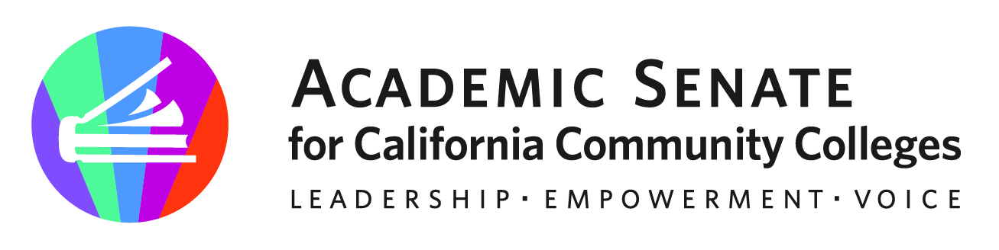

ASCCC AREA D MEETING

March 25th, 2023

9:00am-2:00pm

https://sdccd-edu.zoom.us/j/88541147930

AGENDA

- Call to Order, Adoption of the Agenda
- Welcome & Introductions: https://padlet.com/ManuelJVelez/spring-area-d-meeting-introductions-axuwjtba9lma7lxl
    - ASCCC Presidents Report – ASCCC President
    - ASCCC Foundation Report- ASCCC Foundation
- Resolutions
    - Review of Resolutions Process
    - Review of Packet
    - Additional Resolutions from the Area
- Disciplines List
    - Timelines
    - Proposals
    - Hearings
- Reports and Updates from Local Colleges: https://padlet.com/ManuelJVelez/spring-area-d-meeting-college-reports-and-updates-e99p3abq6qr4mbxl
- Announcements/Events
- ASCCC Webinars on ASCCC Events Calendar
- 2023 Spring Plenary (April 20-22, 2022)
- 2023 Faculty Leadership Institute (June 15-17, 2023)
- 2023 Curriculum Institute (July 12-15, 2023)
- Adjournment

Use the QR Code below to tell us your name and your college | Use the QR Code below to let us know what’s happening at your college
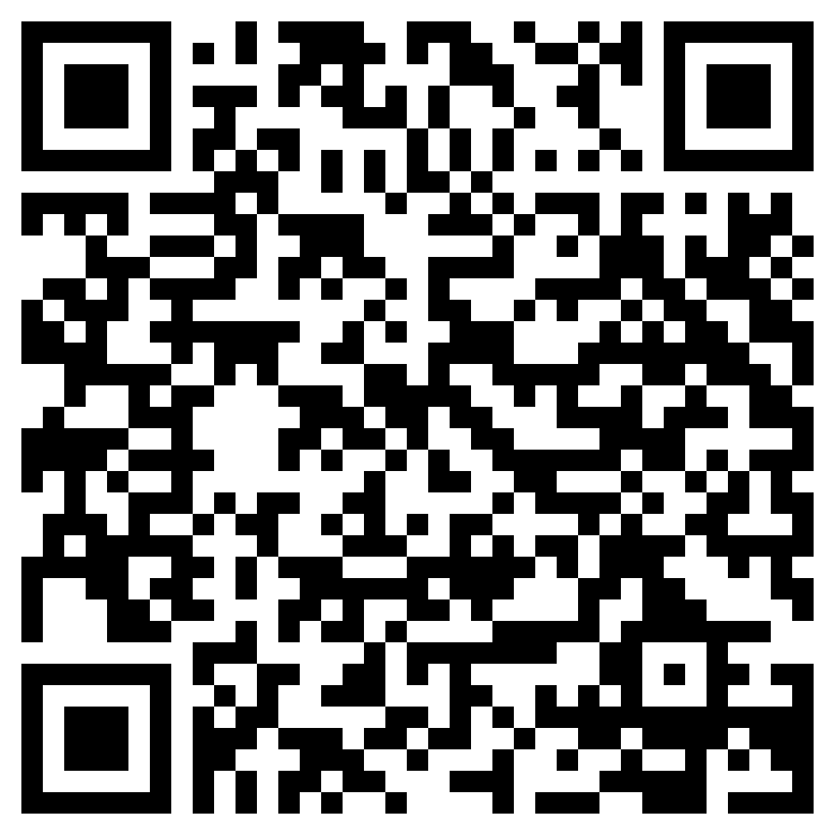 | 