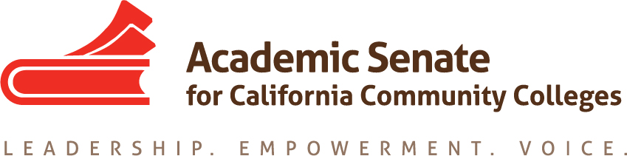

ACADEMIC SENATE FOR CALIFORNIA COMMUNITY COLLEGES
AREA A MEETING
Friday, October 11, 2018
10:00 - 3:00
(Continental Breakfast at 9:30)

Woodland Community College, Room 318 (Building 300)
Zoom URL: https://cccconfer.zoom.us/j/178433743

- Welcome

- ASCCC Update—John Stanskas, President, ASCCC

- Interaction with Eloy Ortiz Oakley, Chancellor, California Community Colleges

- Academic Senate Foundation for CCC

- Disciplines List Revisions
    - Review of Process
    - Proposals submitted:
      - Film Studies
      - Registered Behavior Technician
    - Hearing: Thursday, November 7, 5:30pm, Renaissance Newport Beach Hotel (during Plenary Session)
- Resolutions
  - Resolutions process overview – Julie Clark, Resolutions Committee
    - Resource: Resolution Writing and General Advice
  - Review and Discussion of Pre-session Resolutions
  - Discussion and Development of Area A Resolutions

- Upcoming Area A Meetings:
  - Spring: March 27, Madera College
  - Volunteers to Host Fall 2020 Meeting

- Reports from Colleges

- Announcements

  - 2019-2020 Awards Nominations
    - Exemplary Program Award –Application Deadline: Monday, November 4, 2019 - 5:00pm
    - Hayward Award Deadline- Application Deadline: Friday, December 13, 2019 - 5:00pm
    - Stanback-Stroud Diversity Award: Application Deadline: Friday, February 14, 2020 - 5:00pm

  - Upcoming Events
    - Guided Pathways Webinar: Bridging the Gap between Instruction and Student Services—October 23, 12:00pm-1:00pm
    - Fall Guided Pathways Regional Meeting – North—October 24, 10:30am-3:00pm, Lake Tahoe Community College
    - Open Educational Resources Initiative In-Person Event – Northern California—October 18, 9:00am-3:00pm, Embassy Suites – Sacramento Riverfront Promenade
    - Fall Guided Pathways Regional Meeting – South—October 25, 10:30am-3:00pm, Alan Hancock College
    - Open Educational Resources Initiative In-Person Event – Southern California—October 26, 9:00amp3:00pm, Anaheim Marriott Suites
    - Fall Curriculum Regional Meeting – North—November 1, 9:30am-3:00pm, Folsom Lake College
    - Fall Guided Pathways Regional Meeting – North—November 1, 9:30am-3:00pm, Folsom Lake College
    - Fall Guided Pathways Regional Meeting – South—November 1, 10:30am-3:00pm, Victor Valley College
    - Fall Curriculum Regional Meeting – South—November 2, 9:30am-3:00pm, Los Angeles Pierce College
    - Fall Plenary Session—November 7-9, Renaissance Newport Beach Hotel
- Adjournment – See you at Plenary!

Thanks to Academic Senate President Christopher Howerton and Woodland Community College for hosting this meeting!

