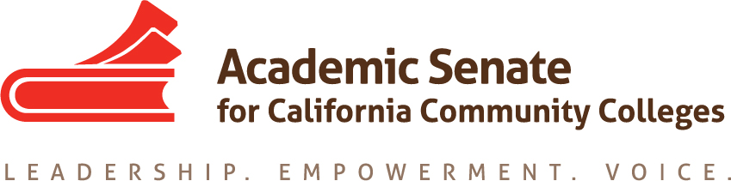

ACADEMIC SENATE FOR CALIFORNIA COMMUNITY COLLEGES
AREA A MEETING
Friday, October 12, 2018
10:00 - 3:00
(Continental Breakfast at 9:30)
College of the Sequoias
915 S Mooney Blvd, Visalia, CA 93277
Sequoia Building, Room 1

- Welcome and Introductions

Geoffrey introduced COS President Brent Calvin. President Calvin welcomed all to the meeting and thanked all for the work that they do with the academic senate locally and statewide.

Participants introduced themselves.

- Area A Meetings
- Spring 2019 Meeting – 3-22-2019 at West Hills, Lemore – if not then Delta is a back-up plan
- Fall 2019 Meeting – Woodland College

- Plenary Sessions
- Fall 2018 – November 1-3
- Spring 2019 – April 11-13

- Reports
- ASCCC Update – Dolores Davison, Vice President

President’s reports have gotten more lengthy and detailed due the additional happenings statewide. John Stanskas is sending the President’s Report to every other constituent group in the state: CIO, CEO, ACBO, CCLC, legislature, and so forth. The four major areas of focus where the ASCCC is asserting our purview in regard to academic and professional matters are Guided Pathways; AB 705; Faculty Diversification, especially around hiring – forthcoming regional meetings at Butte and Bakersfield; Strong Workforce – CTE Minimum Qualifications and Credit for Prior Learning.

Legislative cycle just ended.

The ASCCC has been going into closed session a number of times. The ASCCC does not fall under the Brown Act nor the Bagley Keene, but tries to follow Bagley Keene requirements. The only reasons we go into closed session are due to personnel matters or Board of Governors interviews. The ASCCC does not hire BoG candidates; they send forward names and the governor chooses. The reasons the ASCCC has been in closed session were shared. The ASCCC is working to hire an Executive Director by the first of the year. The membership of the BoG has changed quite a bit. The governor has been replacing BoG members after their one or two terms are up.

Funding formula and other state-level issues were discussed.

- ASFCCC
- Area Competition – the report was shared and there will not be a competition this fall plenary.

- Awards
- Nominations for Exemplary Program Award – Due November 5, 2018 – The theme is Environmental Responsibility

- Disciplines List
- Overview of Disciplines List Revision Process
- Submitted Proposal—Homeland Security
- Other ASCCC Events
- AB 705 Regional Meeting, October 6
- Fall Curriculum Regional North, November 16-17
- Student Learning Outcomes (SLO) Symposium, January 25
- 2019 Part Time Faculty Institute, February 21-23, 2019, Newport Beach Marriott Hotel and Spa
Dr. Jennifer Vega La Serna, Vice President, Academic Services came in to the meeting to welcome us and complicated both the local and state academic senates.

- Resolutions
- Resolutions Process Presentation
- Review and Discussion of Pre-Session Resolutions
Resolutions in packets were considered.
Six new resolutions were considered.
- Development and discussion of Area A resolutions (Resolution Writing Advice)

- Reports from Colleges

- Adjournment

