AREA C MEETING
Saturday, March 28, 2020
9:00 a.m. to 3:00 p.m.

Los Angeles Southwest College
1600 W. Imperial Highway, Los Angeles, CA 90047
Building/Room: Multipurpose Room
PARKING: Use Lot 3 or Lot 4
(PARKING PERMIT and MAP--see https://asccc.org/content/area-c-meeting-spring-2020)

ZOOM INFO
Meeting ID: 255 581 735
Join from PC, Mac, Linux, iOS or Android: https://cccconfer.zoom.us/j/255581735
Or iPhone one-tap (US Toll): +16699006833,255581735# or +16468769923,255581735#
Or Telephone Dial: +1 669 900 6833 (US Toll) +1 646 876 9923 (US Toll)

AGENDA

9:00 a.m. Continental Breakfast and Sign In
9:30 a.m. Welcome: Robert Smith, LA Southwest College Academic Senate President
Introductions Activity
Volunteer Notetaker
Approval of Fall 2019 Meeting Summary
Area C Future Meeting Locations
- Fall 2020: Mt. San Antonio College in Walnut
- Spring 2021: LA Mission College in Sylmar

10:00 a.m. ASCCC Update: President John Stanskas
Conversation and Q&A with Chancellor Eloy Ortiz Oakley
11:00 a.m. Academic Senate Foundation for CCC Update: Anna Bruzzese, South Representative
Foundation Competition Reminder
Disciplines List
- Overview of Disciplines List Revision Process
- February—Request for Proposals
- September—Final Call for Proposals (due September 30) and Summary of Submitted Proposals Distributed
- October—Proposals Discussed at Area Meetings and Written Testimony Submitted to ASCCC Office
- November—First Hearing and Testimony Collected
- January/February—Proposals Reviewed by ASCCC Executive Committee
- March—Summary of Proposals to Area Meetings for Second Hearing
- April—Second Hearing and Plenary Vote to Recommend Changes to Disciplines List

- Second Hearing at Spring Plenary: Registered Behavior Technician (see Addendum A—page 3)

Reports from Colleges, Appreciations and Shout Outs

12:00 p.m. Lunch
12:30 p.m. Resolutions Process Overview: Nate Donahue, ASCCC Resolutions Committee 2nd Chair (click here for Resolution Handbook)
Pre-Session Resolutions Review
Area C Resolutions (see Addendum B—page 8)
2:45 p.m. ASCCC Upcoming Events
- Career and Noncredit Education Institute: April 30-May 2, 2020
- Faculty Leadership Institute: June 18-20, 2020
- Curriculum Institute: July 8-July 11, 2020
- Academic Academy: October 8-10, 2020
- Fall Area Meeting: October 17, 2020
- Fall Plenary: November 5-7, 2020
- Spring Area Meeting: March 27, 2021
- Spring Plenary: April 15-17, 2021
Announcements
Contact Info
- Need anything? Email info@asccc.org
- Text or call Michelle at 562-457-0616

3:00 p.m. Adjournment

Addendum A: Disciplines List Revision Proposal—Second Hearing

ACADEMIC SENATE FOR CALIFORNIA COMMUNITY COLLEGES DISCIPLINES LIST REVISION PROPOSALS

PROPOSAL:
Proposed New Discipline: Registered Behavior Technology
Organization: Moorpark College Academic Senate

Proposed Minimum Qualifications:

Master's in behavior analysis, education, or psychology
OR
the equivalent
AND
certification as a Board Certified Behavior Analyst (BCBA) as set by the Behavior Analyst Certification Board (BACB).

Rationale:

Recent legislative actions requiring the certification of all professionals involved in Applied Behavioral Analysis have created a demand for individuals in the Registered Behavior Technician (RBT) occupation. The RBT is a paraprofessional who practices under the supervision of a Board Certified Behavior Analyst (BCBA) or Board Certified Assistant Behavior Analyst (BCaBA). The RBT is primarily responsible for the direct implementation of behavior-analytic services working with children and adults with impairments such as autism spectrum disorders, developmental disabilities, or traumatic brain injury. The average salary of an RBT in California is $20 per hour. The short-term nature of this training combined with its potential for gainful employment in a meaningful career make this discipline a good fit for the California Community Colleges.

To become an RBT, eligible candidates must:
• Be at least 18 years old
• Hold a high school diploma or the equivalent
• Complete at least 40 hours of training
• Pass a criminal background check
• Pass the RBT Competency Assessment
• Pass the RBT exam
The required training component to become an RBT is approximately equivalent to a 3-unit course. Currently, the RBT training available is provided by private companies and individual
professionals or service organizations. These options can result in a higher fee for training or potentially less effective training than what could be offered through an accredited community college. RBT training must be sufficiently rigorous and effective to prepare the individual to both demonstrate required clinical competencies and pass the certification exam. Sh1dents may elect to complete the RBT program alone to gain this certification, or they may combine this training with degree coursework in related fields, such as Education, Child Development, or Psychology. Gaining this certification early in a student's college career also creates a potential income source for students while they earn their degrees.

A new Registered Behavior Technician discipline is required, as the Behavior Analyst Certification Board requirements for individuals training RBTs do not match any existing disciplines as described in the Minimum Qualifications for Faculty and Administrators in California Community Colleges.

Consultation with Professional Organization:

The California Association for Behavior Analysis has signaled their support for the proposal (see attached letter).

Demonstrated Balance of Need across the State and Discipline Seconder from another District

The proposal is seconded by Thesa Roepke (Early Childhood Studies, Alan Hancock College). Additional support has been indicated by Donna Greene (Early Childhood Education, College of the Desert) and Adrienne Seegers (Childhood Development, Columbia College)

Testimonies:
Testimonies can be in the form of written email, letters sent to the ASCCC Office, or oral testimonies made by individuals at the Fall 2019 Plenary Session.

Name | College/Organization | Testimony | Position

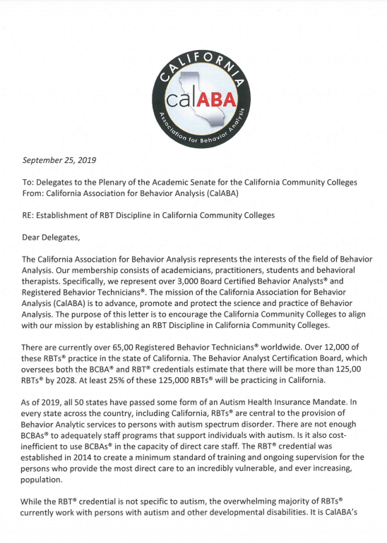
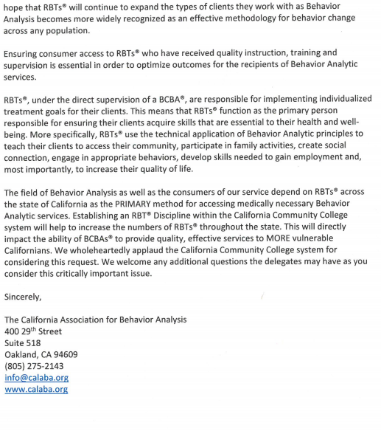

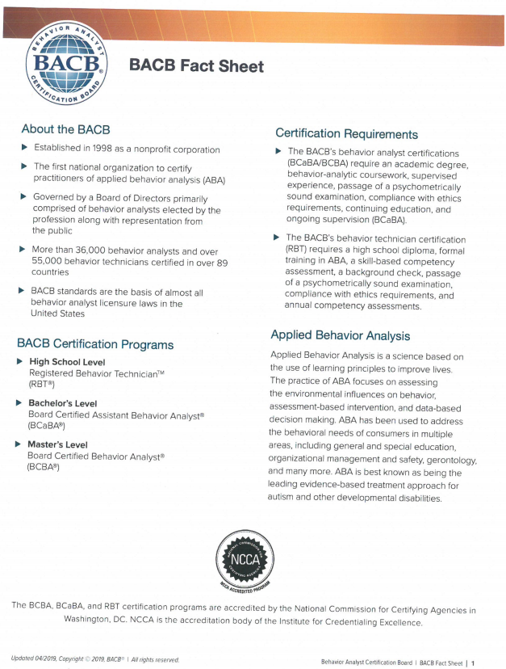
Addendum B: Area C Proposed Resolutions

