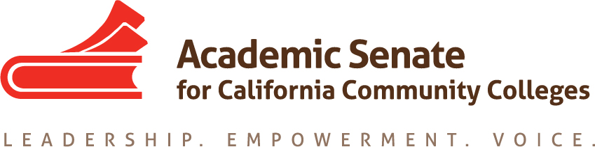

ACADEMIC SENATE FOR CALIFORNIA COMMUNITY COLLEGES
AREA C MEETING
Saturday, October 14, 2017
10:00 am - 3:00 pm
(Continental Breakfast at 9:30)
Teaching Zoo Tour to follow meeting (3-4 pm)

Moorpark College
EATM Building (Exotic Animal Training and Management)

- Welcome and Introductions

- Area C meeting for Spring 2018–Fall 2018?
  - Spring 2018
  - Fall 2018

- Reports (given during lunch)
  - ASCCC Update – John Stanskas, Vice President, ASCCC
    - Guided Pathways
    - Budget
    - Vision for Success
    - Legislative Updates
  - Academic Senate Foundation for CCC, John Freitas, ASCCC Foundation Secretary
    - Foundation Elections
    - Area Competition – Donate here for new trophy!
  - Awards
    - Nominations for Exemplary Program Award – Due November 6, 2017
    - Area C Readers for Hayward Award – Due December 22, 2017
    - Nominations for Stanback-Stroud Diversity Award – Due February 5, 2018
  - Disciplines List, John Freitas, ASCCC Treasurer
    - Overview of Disciplines List Revision Process
    - Submitted Proposals

- Resolutions
  - Resolutions process overview – Michael Dighera, Area C Representative on Resolutions Committee
    - Resource: Resolutions Handbook
  - Review and discussion of pre-session resolutions
(Click “Resolutions” to download the resolutions packet and the appendices)
  - Development and discussion of Area C resolutions

- Reports From Colleges

- Announcements
  - Meetings/Institutes – Registration Now Open!
    - CTE Regional Meeting (Chaffey College) – October 21, 2017
    - Civil Discourse and Equity (Fullerton College) – October 28, 2017
    - Fall Plenary Session (Irvine Marriott) – November 2 – 4, 2017
    - Curriculum Regional Meeting (Cuyamaca College) – November 18, 2017
    - Accreditation Institute (Wyndam Garden Grove) - February 23 – 24, 2018

  - Upcoming Executive Committee Meetings
    - November 1, 2017, Irvine Marriott
    - December 1-2, 2017, Residence Inn Marriott, Sacramento
    - February 2 – 3, 2018, Westin South Coast Plaza

- Adjournment – See you at plenary!

