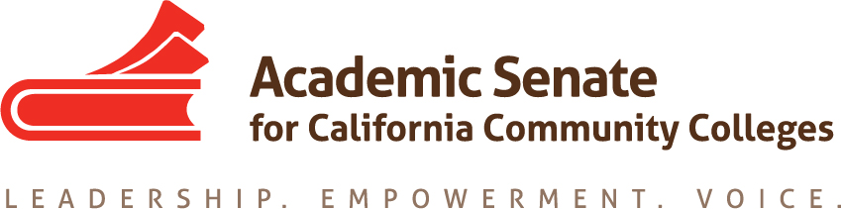

ACADEMIC SENATE FOR CALIFORNIA COMMUNITY COLLEGES
AREA D MEETING
Saturday, October 14, 2017
10:00 - 3:00
(Continental Breakfast at 9:30)

Fullerton College
321 E. Chapman Ave
Fullerton CA, 92832

200 Building – Room 224

- Welcome and Introductions

- Review of Notes from Spring 2017 Area D Meeting

- Area D meeting for Spring 2017– Saturday, March 24, 2018 at Crafton Hills College
  - Fall 2018 meeting - Location?

- Reports
  - ASCCC Update – Julie Bruno, President, ASCCC
    - Guided Pathways
    - Budget
    - Vision for Success
    - Legislative Updates
  - Awards
    - Nominations for Exemplary Program Award – Due November 6, 2017
    - Area D Readers for Heyward Award
  - Disciplines List – Craig Rutan
    - Overview of Disciplines List Revision Process
    - Submitted Proposals
- Resolutions
  - Resolutions process overview – Craig Rutan
  - Review and discussion of Fall 2017 Resolutions
(Click “Resolutions” to download the resolutions packet and the appendices)
  - Development and discussion of Area D resolutions

- Reports From Colleges

- Announcements
  - Meetings/Institutes – Registration Now Open!
    - CTE Regional Meeting (Chaffey College) – October 21, 2017
    - Civil Discourse and Equity (Fullerton College) – October 28, 2017
    - Fall Plenary Session (Irvine Marriott) – November 2 – 4, 2017
    - Curriculum Regional Meeting (Cuyamaca College) – November 18, 2017
    - Accreditation Institute (Wyndam Garden Grove) - February 23 – 24, 2018

  - Upcoming Executive Committee Meetings
    - November 1, 2011, Marriott Irvine
    - January 12 – 13, 2018, Mission Inn, Riverside, CA
    - February 2 – 3, 2018, Westin South Coast Plaza

- Adjournment – See you at plenary!

