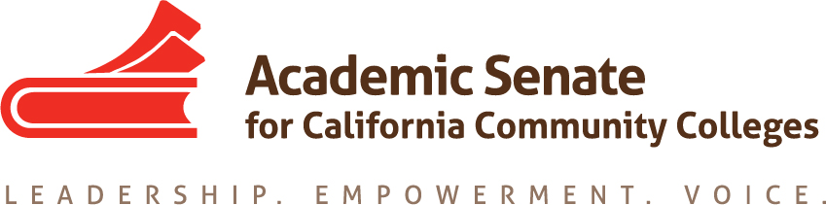

Basic Skills Committee

10 October 2017

8:15-9:15am

CONFERENCE CALL INFORMATION
Participant Passcode: 292286
Toll free number available: 888-450-4821

AGENDA

- Call to Order and Adoption of the Agenda – 8:15am

- Status of Previous Action Items
  - Assigned Resolutions (strikethroughs indicate completed resolutions)
    - Change of funding structure
  - Assigned Tasks
    - Potential for gathering together disciplines - summit
    - Work with TASSC
      - Contextualization
      - What parts of the guided pathways discussions involve basic skills
      - Acceleration

- Status of Committee Priorities for 2017-2018
  - Funding resolution – completed

- Plenary Planning or Report
  - Breakout at Plenary – Katie maybe
  - Basic Skills and Equity--
- Topics
  - Guided Pathways and Basic Skills

- Announcements
  - Events
    - Area Meetings 13/14 October 2017
    - CTE Regionals 20/21 October 2017
    - Civil Discourse/Equity Regionals 27/28 October 2017
    - Executive Committee Meeting 1 November 2017
    - Plenary 2-4 November 2017

- Adjournment

