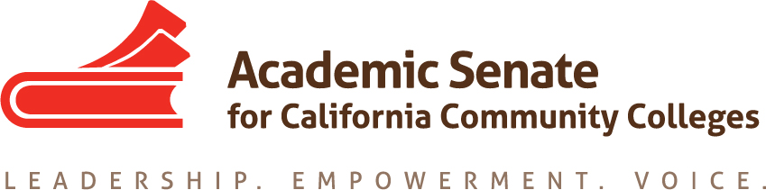

Basic Skills Committee

Thursday August 30th, 2018

4:00 PM – 5:30 PM

Join from PC, Mac, Linux, iOS or Android: https://cccconfer.zoom.us/j/3285687631

Or iPhone one-tap (US Toll): +14086380968,3285687631# or +16468769923,3285687631#

Or Telephone:

Dial:

+1 408 638 0968 (US Toll)

+1 646 876 9923 (US Toll)

Meeting ID: 328 568 7631

- Order of the Agenda
- Welcome and Introductions
- Review of Committee Charter

The Basic Skills Committee reviews policies and recommends to the Executive Committee positions and actions on issues related to meeting the needs of under-prepared community college students. In addition, the Basic Skills Committee gathers information on best practices in providing instruction and support services to under-prepared students and conveys this information to the field through breakouts, workshops, and papers. Members of the Basic Skills Committee represent the Academic Senate on such bodies as the System Office Basic Skills Advisory Committee.

- Review of Assigned Resolutions
- AB 705
- Possible Regional Meetings
- Future Meeting Dates
- Other

