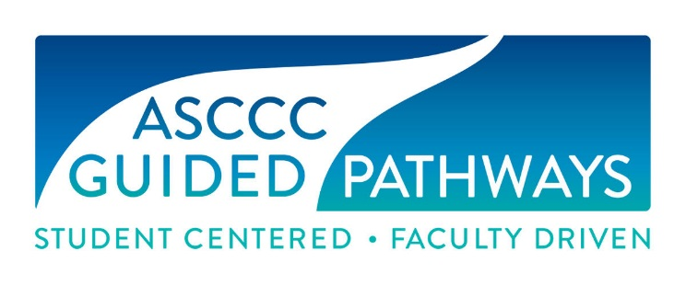
CB21 Rubric Updating Ground Rules
AB 705 Data Revision Project Recoding Regional Meeting

- Today’s Goal:
  - Whittle down the draft rubrics
  - Determine broad outcomes that define course level – not detailed course content – using existing CB21 rubrics, C-ID courses, and EFLs
  - Consider column/domain titles – are they ok – do we NEED to change them? They are modeled on existing CB21 and EFLs and yes there is overlap

- We are NOT:
  - Word-smithing
  - Debating AB 705, SCFF, merit or mode of curricular offerings

- The Recommendation:
- Integrate outcomes related to quantitative reasoning, English/reading courses, and ESL from the federal Educational Functioning Levels (EFL) already in use by noncredit programs and K12 adult schools.
- Integrate outcomes from C-ID approved courses.
- ASCCC will hold regional meetings to gather feedback about the revised rubrics for math and English this March, and bring the rubric to the spring plenary.
- ESL will continue to work on its rubric through the spring, for review at the Curriculum Institute and over the summer.
- The new rubric will enable faculty to document the levels of skills that students will have attained by the end of a broader range of pre-collegiate courses, such as pre-statistics.
- Having one consolidated rubric will facilitate alignment between credit, noncredit, and adult schools and allow for mirrored courses and transition from adult education and noncredit to credit.
- The element will continue to be used to determine skills gains in contexts like AB 705, the Student Success Metrics, and the Adult Education Program.

- The Rubrics:
- The rubrics are outcomes that demonstrate course level and not all of the learning outcomes of every course—they indicate an educational level that student has attained.
- Each level has a broad description of the outcomes a student should have attained by the end of the course at that level. The description is not intended to include all student learning outcomes of each course at that level, but rather indicate an educational level that student has attained.
- Included are outcomes that define the traditional levels as well as outcomes that define the Common Core State Standards or EFLs.
- A narrative with far more information on potential content will be included.
- New coding integrates outcomes updated with current expectations from the Federal Educational Functioning Level (EFL) descriptors, based on common core standards
- New coding identifies and helps track student progress for AB 705 and Student Centered Funding Formula (SCFF) time to completion metrics.
- The new coding identifies the level at which the student should be upon completion of a course in a pathway. A level typically indicates one-year of high school course work at a standard pace, neither accelerated, nor stretched. This generally is interpreted to be one-term at a standard college pace.
- There may be additional levels below transfer that did not exist prior to 2019. This is due to including noncredit, Adult Basic Education (ABE) and Adult Secondary Education (ASE) in the same rubric with credit courses.
- All in same rubric to facilitate alignment between credit, noncredit, and adult schools and allow for mirrored courses and transition from adult education and noncredit to credit.
- Rubrics for English integrate reading and critical thinking outcomes.
- Rubrics for mathematics and quantitative reasoning include statistics, geometry, contextual mathematics and mathematical critical thinking outcomes.
- All rubrics reference integrated skills such as communication and problem solving.

- The Rubrics do NOT…
- Drive curricular content or pedagogy;
- Directly reflect EFLs but they do adapt them to CCC curriculum with accurate, yet concise descriptions;
- Dictate any particular innovation, program or course strategy;
- Determine or dictate sequences or prerequisites for any particular course.

- CB Codes:
- CB21 Identify content of English, math, ESL and related discipline courses using rubrics created by discipline workgroups based on EFLs, vetted by faculty statewide, approved by ASCCC delegates at 2019 spring plenary session – As of February 26, this coding be rolled into CB21 and the CB21 rubrics will be updated.
- CB25 – Identify GE requirement or local competency: CSU GE Breadth/IGETC—B4/2A (math/QR) and A2, A3/1A (English Comp/Critical Thinking), local GE/competency
- CB26 – transfer type: major, GE, elective, where to: CSU, UC, other college
- CB27 – support course type, as of February 26, this is a binary code: support course or not a support course

The PLAN Recap

Create new data elements, in particular:
- CB21 Identify content of English, math, ESL and related discipline courses using rubrics created by discipline workgroups based on EFLs, vetted by faculty statewide, approved by ASCCC delegates at 2019 spring plenary session – As of February 26, this coding be rolled into CB21 and the CB21 rubrics will be updated.
- CB25 – Identify GE requirement or local competency: CSU GE Breadth/IGETC—B4/2A (math/QR) and A2, A3/1A (English Comp/Critical Thinking), local GE/competency
- CB26 – transfer type: major, GE, elective, where to: CSU, UC, other college
- CB27 – support course type, as of February 26, this is a binary code: support course or not a support course

Timeline:
- March 2019 – New Data elements are being created by Chancellor’s Office
- April 2019 – Academic Senate to consider updated CB21 Rubrics
- May 2019 – July 2019 – webinars and training to take place
- July 2019 – Sessions and training at the Curriculum Institute will be offered where faculty can begin to code their courses with support from curriculum experts.

