CNEI CPL General Session Activity May 1, 2021

College | 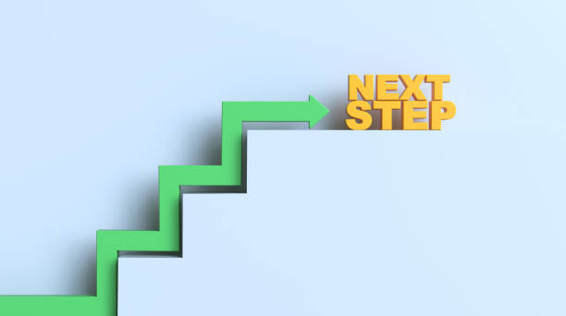  What would be the next step? | What question would you ask?
Los Medanos College | Visits from other colleges to share out/dialogue groups/faculty workgroups...help faculty see it doesn’t have to be that hard | It would be great if there were state-wide discipline groups for CPL
 |  | ^-- include noncredit as one of these groups :)
Riverside City College | Ask disciplines to see where they are at with CPL | Are there webinars that we can share with our faculty about CPL?
San Diego Mesa College | Have created a Task Force to begin discussions about how to best approach CPL and introduce it to the Senate, faculty, and the campus.  Looking beyond credit by exam to identify best ways to make CPL equitable for all students. | Who are all of the stakeholders who need to be involved?  Be helpful to have an on-going workgroup at the State level.
San Diego College of Continuing Education | Student Outreach workgroups are in process of meeting to review student journey and support areas for Credit By Exam | Identify gaps in student awareness and guidance in current process, on-going meetings to assist student participation and success in Credit By Exam

