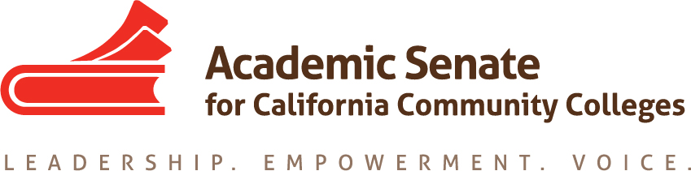

Career Technical Education Leadership Committee

December 7, 2020

9:00-10:30am

MEETING MINUTES

- Welcome

- Call to Order, Roll Call and Adoption of the Agenda

- Check-in- Rose, Thorn or Bud

Mayra Cruz, Julie Oliver, Jim Bowen, Donald Laird, Lynn Shaw, Christie Dam, Kristina Perkins, Christy Coobatis, Violets Wenger, Tine McClurkin, David Ramirez

- Consent Agenda

  - Approval of the November 18 meeting minutes (Attachment 1)-Approved

- Reports (30min)
- Student Senate CCC Anti-Racism: A Student Plan of Action (David)
  - Hosted a few town halls to hear from students
  - Reviewed highlights from the Plan of Action areas including Cultural Awareness, Equity Training, Changes to the Curriculum, Peer Mentors and Alliances, Classroom Experience
  - Application to CTELC & Solutions
    - Reach out to POC business owners when seeing relationships with local organizations and businesses
    - Acknowledge the student outcome data coming from CTE/Non-credit programs, and base your work on the understanding coming from the data
  - Gathering Workforce Data
  - Question from committee-how this committee or senate may help in these efforts? Is SSCCC talking about impact of white privilege?
  - Committee will be asking for students to join a panel for one of the General Sessions at the Institute. Also interested in integrating the student voice into other sessions of the event.
  - Rostrum article possible topic highlighting need to reach out to POC business owners, or article about gathering and analyzing data for CTE.
    - ACTION: David will try to put an outline together to start moving toward a January deadline. Mayra to work with David.

- Academic Senate CCC December 4-5 meeting highlights (Mayra/Julie)
  - No adopted Fall Plenary resolutions were assigned to this committee
  - FELA-program launching in February for mentee and mentors
  - ASCCC Periodic Review now occurring-outside team of faculty will be completing the review
  - Part Time Faculty Institute program was reviewed
  - CT and Noncredit Institute-sessions per breakout may be decreased because of low attendance expectations

- Jan-May 2021 Calendar of Meetings-please complete the DoodlePoll, only 7 answered as of this meeting time
  - Friday January 22nd 12:00pm-1:30pm
  - Thursday February 25th 10:00am-11:30am
  - Thursday March 18th 10:30am-12:00pm

- Rostrum articles (due to Mayra Jan 2)
  - Topic/s and writers
    - CTE faculty have a voice at the state level (Christy, Julie, Lynn & Mayra)
      - Outline being worked on in GoogleDocs
    - SSCCC article with David and Mayra

- Focus Areas Teams Report (Leads and members)
- Committee priorities-no report

- Communication and Support to CTE Liaisons-no report, all sessions placed in BaseCamp Calendar
  - Coffee Hour Calendar/Facilitators/Topics (Lynn)
- November 18 4-5 CTE Survey (Done)
- February 9 11-12 Perkins Funding
- March 18 11-12 Credit for Prior Learning
- April 6 2-3 Minimum Qualifications
- May 6 1-2 Preparing for the next academic year

- Professional Development and Learning
  - 20-21 Program working document (Attachment 2)
  - Career Noncredit Education Institute (April 30-May 2, 2021)
      - Update on final program outline (Attachment 3)
      - Next Joint meeting 12/8 at 2:30pm
- review and incorporate the Exec. Committee's input and other input
- assign leads and presenters, prepare breakout descriptions, and review the steps to finalize the Institute's program and timeline
- Reviewed the ASCCC Exec Committee feedback and made some edits to the program outline
- Will need to consider reducing the number of sessions in each breakout, but hold sessions to be added back in registration is robust
- Adjournment

Status of Previous Action Items

- In Progress (include details about pending items such as resolutions, papers, Rostrums, etc.)
- PD Program for 20-21
- Rostrum article/s (Jan)
- Committee priorities update
- CNEI Program
- Spring 2021 Resolution topics

- Completed (include a list of those items that have been completed as a way to build the end of year report).
- CTE Liaison coffee hour schedule
- October & November 2020 CTE Liaison Memo
- Committee charge review
- Fall 2020 Plenary breakout assignments
- 20-21 Action Plan components review and formation of focus area teams (3)
- CNEI Marketing blurb
- Fall Rostrum article Credit for Prior Learning as an Equity Lever Co-Authors: Jackie Martin, Chantee Guiney, Jodi Lewis & Mayra Cruz
- Basecamp set up
- Fall 2020 calendar of meetings
- CCCAOE Conference Sept 30-Oct 2, 2020 (Shaw)
- Focus area team plans
- Focus area team lead role

Career Technical Education Leadership Committee (CTELC)
approved 11/4/20

The CTE Leadership Committee provides recommendations on career and technical education and workforce development issues and challenges in the California community colleges. The committee works collaboratively with the ASCCC Executive Committee to assist community college districts, CTE departments, and CTE faculty to ensure that career technical education and workforce development provide responsive curriculum aligned to current and emergent industry trends, and to focus on diversity, equity, and inclusion in all aspects of career education. The committee is also focused on diversity by expanding the participation of diverse CTE faculty in leadership roles at the local, regional, and statewide levels through its ongoing professional development efforts.

