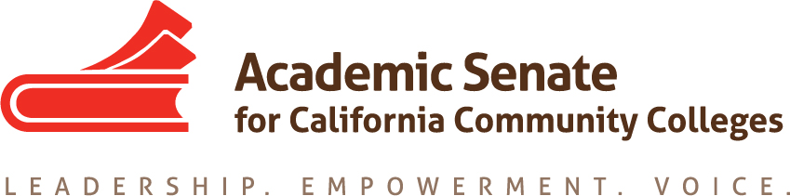

Curriculum Committee

Date: Tuesday, 21 March, 2017

8:30 AM – 10:00 AM

Minutes

- Call to Order: 8:34 a.m.

- Approval of the Agenda: Approved

- Approval of 25 February 2017 minutes: Approved

- Discussion items, with action as needed
  - Curriculum Institute Program update
    - Pre-session strands: last year had 20-45 attendees depending on the strand. Curriculum specialists were invited to attend this year, which may increase their attendance.
    - General sessions are set
      - The four sessions are set.
        - Chancellor’s Office: Pam Walker, Jackie Escajeda, Virginia Guleff, and Dolores Davison are set for the first general session.
        - Civil Engagement: Thanks to Michael Wyly for writing the description. The panel is to be determined.
        - Pathways: Rob Johnstone will be speaking
        - Chancellor’s Office Certification Training: The intent is to provide an engaging breakout that outlines the training required for local certification.
    - Additional suggestions for breakouts: 64 breakouts may not be enough if there are 600 attendees. If there are presentations that can/should be duplicated, let Dolores know.
    - Descriptions/presenters due: Dolores will update these from past years. If committee members are interested in a topic, they should let Dolores know. Committee members can serve as facilitators or presenters. Dolores will fill in gaps as needed. Exec Committee members will be presenting as well.
  - Upcoming Curriculum Regionals: Regionals are going well. Several committee members have been able to attend and/or assist in regional trainings, including Michael Wyly, Karen Daar, and Dan Keller. Additional regionals are upcoming. All committee members are welcome to attend.
    - 17 April at College of Marin
    - 26 April at Long Beach CC
    - 28 April at Cabrillo
    - 12 May at Butte
    - Las Positas, Irvine Valley, San Diego, Chaffey, Clovis TBD (may be in fall)
  - Plenary Session breakouts: Plenary sessions are set.
    - Curriculum Panel: A curriculum panel will present at the first general session.
    - Curriculum Panel follow up: This will be later in the day after Consultation Council meets.
    - Dual Enrollment: Michael Wyly will be presenting with Dolores.

- Announcements
  - Executive Committee Meeting Wednesday, 19 April at San Mateo Marriott
  - Plenary Session, 20-22 April at San Mateo Marriott
  - CTE Leadership Institute, 5-6 May at San Jose Marriott
  - Noncredit Summit, 4-5 May at Sacramento Marriott Rancho Cordova

- Adjournment: 9:14 a.m.

