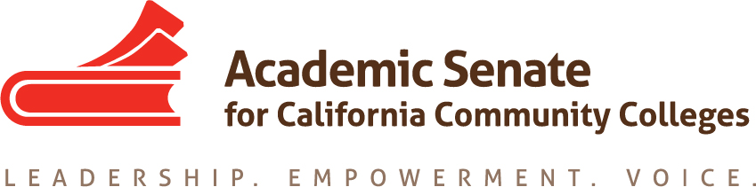

President
Dolores Davison
Foothill College

Vice President
Virginia “Ginni” May
Sacramento City College

Secretary
Cheryl Aschenbach
Lassen College

Treasurer
Mayra Cruz
De Anza College

Area A Representative
Julie Oliver
Cosumnes River College

Area B Representative
Karen Chow
De Anza College

Area C Representative
Robert L Stewart Jr.
Los Angeles Southwest College

Area D Representative
LaTonya Parker
Moreno Valley College

North Representative
Carrie Roberson
Butte College

North Representative
Stephanie Curry
Reedley College

South Representative
Sam Foster
Fullerton College

South Representative
Manuel Vélez
San Diego Mesa College

Representative at Large
Silvester Henderson
Los Medanos College

Representative at Large
Michelle Bean
Rio Hondo College

Executive Director
Krystinne Mica

SUBJECT: Disciplines List Revision Process

Dear Colleagues:
In February, the process for formally reviewing the Disciplines List, which establishes the minimum qualifications for the faculty of California community colleges, was initiated. This letter serves as a notification that the ASCCC is currently accepting proposals to revise the Disciplines List for the 2021-2022 cycle. As a reminder, the review process is now an annual process. The deadline for submission of proposals is September 30, 2021. Proposals received after the deadline may be held for the 2022-2023 cycle.
Such a review was completed in fall 2020 for Film and Media Studies and Digital Fabrication Technology, and both proposals are now headed for a second hearing, before presentation for final approval by the delegates at the Spring 2021 Plenary Session.
The following resource materials are provided to assist you with developing and submitting proposed changes to the Disciplines List.
- Enclosure 1—Discipline List Proposal Process: This document provides you with a guide to the discipline review process.
- Enclosure 2—Discipline List Review Timeline: This timeline provides information about key deadlines. Please pay attention to the hearing dates, as each proposal must be heard in at least one hearing. Please note that the final day to accept proposals is September 30, 2021.
- Enclosure 3—Revisions to the Discipline List Form: This form is used to submit revisions.
- Enclosure 4 –FAQs on Minimum Qualifications: This FAQs document clarifies some common misunderstandings about minimum qualifications.
Please send this packet of materials to division/department chairs, curriculum committee members, your senators, vice president of instruction, and anyone else that might benefit from this information. All information noted above is available on our website by clicking here. Information regarding the current minimum qualifications can be accessed here.
If you have any questions, please contact us at disciplineslist@asccc.org. Please indicate Disciplines List on the subject line of the email.

