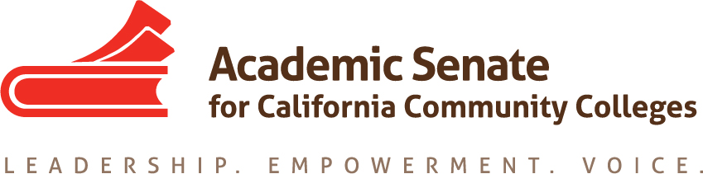

ASCCC Diversity, Equity and Action Committee (EDAC)

Friday October 26, 2018

11:00 A.M. – 1:00 P.M.
Location: Zoom/CC Confer

11:00 A.M. – 11:20 A.M.

- Order of the Agenda
- Roll Call/Membership Review:

EDAC Membership List - (2018 - 2019)

Silvester Henderson, Chair - Los Medanos College - Area B
Conan McKay - Chair (2nd) - Medocino College - Area B
Robin Allyn - Mira Costa College - Area D
Leigh Ann Shaw - Skyline College - Area B
Van Rider - Antelope College - Area C
Khalid White - San Jose College - Area B
Carlos Lopez - Folsom Lake College - Area A
Nathaniel Donahue - Santa Monica College - Area C

- Review of the Minutes from 9-14-2018 Meeting
- EDAC Four Priorities/New Business (Discussions):

- Faculty Diversity & Hiring (I)
- Student Equity, Student Services & Support (II)
- Research & Academic Guides for Equitable Student Success (III)
- Pathways to College Teaching – A2MEND (IV)

(11:20 A.M – 11:50 A.M.)

5. EDAC Priorities
Area I

“Faculty Diversity Hiring & System Partnerships”
Update Status Report:

I
“Chancellor Office/Senate Faculty Diversity Hiring Summit”
Date: 2/8/2019 – 2/9/2019
Location/Time: TBA
EDAC Outcomes: Breakout Suggestions from EDAC to the ASCCC President – Discussions
Assign Committee Member___________________________________________________

II

ASCCC Hiring Regionals (Three)
10:00 A.M – 3:00 A.M.
February 21, 2019 – Bakersfield College (Area A)
February 25, 2018 – Butte College (Area A)
February 28, 2018 – Norco College (Area D)
EDAC Outcomes: Breakout Suggestions from EDAC/FDC Joint Planning Meeting scheduled for
November 29, 2018 – Sacramento City College – 2:00 P.M. – 6:00 P.M. (All invited)
Discussion: Cultural Competence Tools - Breakout (Regionals), Update Resolutions (Spr. 2019)
Assigned Committee Member ________________________________________
Area II
“Student Equity, Student Services & Support”
Update Status Report:

“LGBTQIA”– Expanded Support
Nate/Conan – Rostrum Article Outline Update – Pride Month – Discussion

“DACA Expanded Support”
Leigh Ann/Carlos - Rostrum Articles - Plenary Breakouts (Sp19) – Discussion
“Student Safety & Support/Sexual Assault”
Silvester – Chancellors Office – Emailed 10-21-2018 – Discussion
“Inmate Education”
Silvester – Chancellors Office – Emailed 10-21-2018 – Discussion - (Attachment)
“Corrections to College Sponsored Meeting”
Corrections to College California is a project of Renewing Communities, a four-year initiative designed to build a network of bridges from corrections to college in California. Renewing Communities is a joint initiative of The Opportunity Institute and the Stanford Criminal Justice Center.
New York University McSilver Institute: Trauma Informed & Resiliency Based Project
(Attach PowerPoint)
Chancellor Office Meeting – October 16, 2018
Suggested Action – Breakout – “Prison Education Programs” – Spring 2019 Plenary
Peter Fulks – Cerro Coso College (Interested in Co-Presenting) - Discuss
Assigned Person: Silvester & ___________________________________________
(11:50 A.M. – 12:35 P.M.)

Area III
(45 Minutes)
“Research & Academic Guides for Equitable Student Success” (III)
Update Status Report
A: Student Equity Plan Outline & Original Attached
Assigned Persons/Areas
(Designate who will work on what sections)
Agreed Upon Date of Submission Updates/Outlines

(12:35 P.M. – 12:55 P.M.)
Area IV
“ Pathways to College Teaching”
Update Status Report
A2MEND – Partnership Presentation (March 2019)
(EDAC Chair has been asked to prepare various breakouts for approval & presentation)
Status: A2MEND has not published the date for “Breakout Submissions”
Assigned Person: Silvester & Khalid:___________________________________________
Khalid/Conan – Rostrum Article Outline Update – Discussion
New Business (10 Minutes)

Education Code 87408 (See Attachments)
Discussion/Impact on Faculty – See Attachment
Professor Richard Weinroth – Senate President
“San Diego Continuing Education”
Senate Suggested Action: _____________________________________________________________ ______________________________________________________________

(12:55 – 1:00 P.M.)
6. Future Meeting Dates & Senate Announcements – November 1-3, 2018 – Fall Plenary – Irvine, Ca
7. Final Comments & Wrap Up

