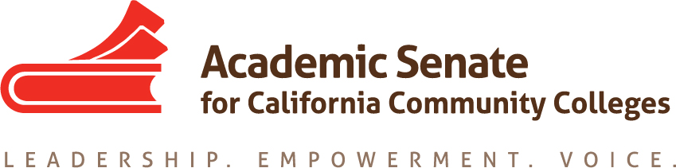

ASCCC Diversity, Equity and Action Committee (EDAC)

Tuesday March 26, 2019

8:00 A.M. – 10:00 A.M.

Location: ZOOM/CC Confer

8:00 A.M. – 8:15 A.M.

- Order of the Agenda
- Roll Call/Membership Review

EDAC Membership List - (2018 - 2019)

Silvester Henderson, Chair - Los Medanos College - Area B
Robin Allyn - Mira Costa College - Area D
Leigh Ann Shaw - Skyline College - Area B
Sandy Somo – Glendale College – Area C
Khalid White - San Jose College - Area B
Michelle Bean – Rio Hondo College - Area C
Nathaniel Donahue - Santa Monica College - Area C

- Review of the Minutes from 1/31/2019
- ASCCC Announcements:
A: ASCCC Open Leadership Positions – Spring 2019 Plenary (Election Form Attached)
C: Spring 2019 Plenary – April 11-13, 2019 (Westin San Francisco Airport/Hotel)
- EDAC Four Priorities (creating from ASCCC priorities):

- Faculty Diversity & Hiring (I)
- Student Equity, Student Services & Support (II)
- Research & Academic Guides for Equitable Student Success (III)
- Pathways to College Teaching – A2MEND/Continued Business (IV)

(8:15 A.M. – 8:35 A.M.)

5. EDAC Priorities:

Area I – (10 Minutes)
“Faculty Diversity Hiring & System Partnerships”
Update Status Report:

I
“IEPI Buidling Diversity Hiring Summit”
Date: 2/8/2019 – 2/9/2019
Location/Time: Gateway Los Angeles Hotel
6101 W. Century Boulevard
Los Angeles, CA 90045
Discuss Regionals – Review/Assessments/Comments
II

ASCCC Hiring Regionals (Three) – (10 Minutes) - Updates
February 21, 2019 – Bakersfield College (Area A)
February 25, 2018 – Yuba College (Area A)
February 28, 2018 – Norco College (Area D)
Discuss Regionals – Review/Assessments/Comments

(8:35 A.M. – 8:55 A.M.)
Area II – 20 Minutes
“Student Equity, Student Services & Support”
Update Status Report:

I

“LGBTQIA”– Expanded Support
Nate* – Rostrum Article – Pride Month – Discussion /Update
A: Article – ASCCC Rostrum Submission – (Article Submitted - Attached)*

“DACA Expanded Support”
Leigh Ann - Rostrum Articles - Plenary Breakouts (Sp19) – Discussion/Update
A: Article – ASCCC Rostrum Submission – (Status Update)
“Student Safety & Support/Sexual Assault”
Silvester – Chancellors Office –– Discussion/Update
A: Possible “Breakout” topic for the Spring ASCCC Plenary (TBD)
B: Title & Description Due: (TBD) – No Report – (Status Update – No Action)

“Inmate Education”
Silvester – Discussion/Update
A: Possible “Breakout” topic for the Spring ASCCC Plenary (TBD)
B: Spring Plenary Approved Breakout (2019) – Prison Education: Cerro Coso College Case Study

(8:55 A.M. – 9:10 A.M.)

Area III – (15 Minutes – Review Goals)
“Research & Academic Guides for Equitable Student Success” (III)
Update Status Report

I
A: Student Equity Plan Outline -Submitted Paper 1-23-2019
Update/Status: ASCCC Executive Committee Recommendations/Suggestions (Attached)

(9:10 A.M – 9:20 A.M)
Area IV (10 Minutes)
Pathways to College Teaching – A2MEND (IV)
Update Status Report:

I
A2MEND – Partnership Presentation (March 2019)
Three Breakouts: PowerPoints Attached
- Increasing Participation and Engagement of Men of Color in STEM
- The Engagement of Equity for African American Males
- Urban Music & Performing Arts – A Equitable Pathway into Higher Education
for Males of Color

II
(9:20 A.M. – 9:50 A.M.)
New/Continued Business (30 Minutes)
Update Status Report
A: Education Code 87408 (See Attachments)
Resolution – Spring Plenary (Leigh Ann/Richard Weinroth)
Update: Spring 2019 Final Resolution Packet – Attached
(EDAC – Resolution 3.01)

B: ASCCC Academic Academy (ASCCC Request - EDAC)
Discussion – Suggestions - Comments

(9:50 A.M. – 10:00 A.M.)
6. Agreed Future Meeting Date:
A: Thursday, May 16th from 3pm-5pm

7. Closing Comments EDAC Committee – Lets Stay Together & Love Each Other!

