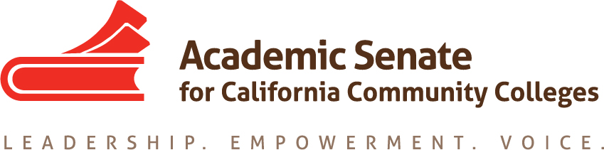

Equity and Diversity Action Committee

15 November 2017, 9am

Call in Information: 888.450.4821
Participant Pin:
585779
Minutes

- Call to Order and Adoption of the Agenda – 9:03am

- Dolores Davison, Sam Foster, Eartha Johnson, Orlando Shannon, Michael Wyly

- Status of Previous Action Items
  - EDAC Regionals Report Out
    - Who are our allies? How do we spread this to a larger group?
    - Academic freedom and safety
  - Plenary Session Breakout Report Out
    - Difference in terms of AB 540/DACA/FERPA issues
    - Student success tied
    - Safety issues around ICE/campus security
    - AB 705 and basic skills
    - Civic Engagement and equity – framing conversations into the trend of the week to engage more people

- Status of Committee Priorities for 2017-2018
  - Paper (see attached outline)
    - Paper will be due to Exec in February so must be completed by mid-January to make agenda – draft due to Dolores 8 January 2018
    - Division of specifics topics per committee member
      - Specific assignments sent to committee members
      - Exec comments integrated into outline

- Plenary Planning or Report
  - Potential new resolutions assigned to EDAC -- equity paper?
- Announcements
  - Events
    - Curriculum Regional 17/18 November, Folsom/Long Beach
    - Executive Committee Meeting 1/2 December, Sacramento
    - Executive Committee Meeting 12/13 January, Riverside

- Adjournment -- 10:15am

