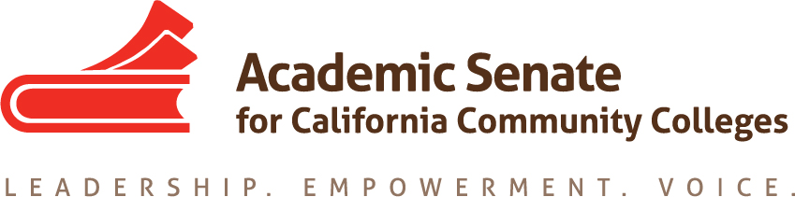

Equity and Diversity Action Committee

20 September 2017

10:30-3pm

Chair’s House, San Jose, CA

AGENDA

- Call to Order and Adoption of the Agenda: 10:33am
  - Dolores Davison (chair), Sam Foster (2nd), Eartha Johnson, Orlando Shannon, Michael Wyly

- Application for Statewide Service – http://asccc.org/content/application-statewide-service

- EDAC Regionals
  - Specifics
    - 27 October at Solano
    - 28 October at Fullerton
    - Participation of committee members
  - General Session Focus on Civil Discourse
  - Topics for breakout sessions – DACA/Basic protections that our students already enjoy and how to communicate this to students; Basic Skills and curriculum and Equity; ADT in Social Justice and social justice campaign on campus – envisioning curriculum as a social justice issue; implications of sanctuary state – how does that empower us, how does it protect us; faculty not recognizing need for equity conversations (how do we prompt this discussion); Celia would present on DACA; what kinds of take aways can we get from these; strategies for broaching these conversations; responsibilities as educators pedagogically and otherwise—why should this matter? In the weeds workshops about effective practices – what tools can you bring back to the campus to aid other faculty
    - Dolores will create program and send to committee for approval
  - Equity from a student perspective
  - Other logistics for sessions

- Plenary Planning
  - Breakout of Civil Discourse
  - Breakout to report current activities/other ideas
    - Initiating on starting these conversation
    - Breaking down silos to better serve equity/SSSP – Equitable Equity
- Other assignments to EDAC
  - DACA website and resources
  - Resolution on Veterans Resource Centers
    - How is it managed?
    - Gender issues
    - What kinds of services are available for students/staff/faculty?
  - Paper on hiring – outline to exec in November

- Announcements
  - Events
- Executive Committee Meeting, 29-30 September, Moreno Valley College
- Fall Area Meetings – 13 and 14 October, locations vary
- CTE Regional Meetings – 20 and 21 October
- EDAC Regionals – 27 and 28 October
- Fall Plenary Session – 2-4 November, Irvine Marriott
- Curriculum Regionals – 17 and 18 November

- Additional Announcements/Issues
- Adjournment

