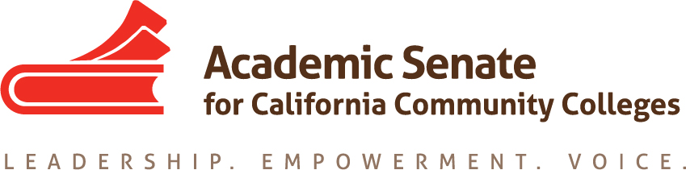

Equity and Diversity Action Committee Meeting

25 August 2017, 9-10am

CCC Confer
Participant Passcode: 955961

Toll free number available: 888-450-4821

Minutes

- Call to Order: 9:03 AM
Adoption of the Agenda—APPROVED with addition of the discussion item, “Discussion of Academic Academy in 2017-18 AY”

- Introductions – Dolores Davison (Chair), Foothill College; Randy Beach, English, Southwestern College (Former Chair); Eartha Johnson, Counseling, Victor Valley College; Michael J. Wyly, English, Solano Community College; Orlando Shannon, Lassen College, Counselor/Psychology; Sam Foster, (Second) Fullerton College (9:24 AM)

- Planned in-person meeting for September

EDAC Future Meetings:

- SEPTEMBER 20, 2017 (IN-PERSON to discuss EDAC Regionals), San Jose, CA (chez Dolores) or Solano Community College, TBD. For in-person meeting, Dolores will provide links to the forms for travel and food reimbursement from ASCCC.
- October 25, 2017, 9-10:30 AM Phone Meeting/CCCConfer
- Rest of dates to be set at in-person meeting on 9.20.2017.

- Topics
  - EDAC Regionals on Civil Discourse (initial draft attached) – 27-28 October 2017
  - Breakout session topics
  - Other foci for general sessions
  - Speakers/possible topics?

Recently, ASCCC Exec has prioritized the topic of civil discourse and views the development of this topic through the lens of equity in effort to develop further dialogues re: civil discourse state-wide.

Preliminary dates are set for both North and South regionals. Oct 27, 2017 (North) and Oct 28, 2017 (South). ASCCC Exec will discuss further this topic at its next exec meeting to provide direction for equity-based conversations, including the forthcoming regionals. Committee reviewed preliminary/example draft of a possible program for 2017 EDAC Regionals.

The focus of last year’s EDAC regionals was faculty diversity with a focus on diversity in hiring. Veronica Neal of Foothill College was the key note speaker. The content of her dialogue contributed to setting the tone for the day, including the facilitation of civil dialogue, as well as a focus on the role of Human Resources and professional development to promote civility and professional development and hiring.

2016 EDAC regional attendance was 60-70 participants in the North; the Southern regional was somewhat less attended.

Possible topics for the upcoming EDAC Regionals on Civil Discourse were discussed. The committee agreed to focus on how we might construct sessions which create the opportunity for good “take-aways” which participants may bring back to other campuses—i.e. how to empower attendees to bring back to campus. Possible topics discussed included: civic engagement; safe spaces for students; how to address cultural dissonance; tools for the college community to communicate more effectively, including the Trustees; difficulties with how to start conversations re: equity in a climate that may or may not recognize local need, including faculty-student disconnect; tools to initiate and continue conversations re: equity on local campuses. Committee to send additional possible breakout topics to Dolores by 8.28.2017.

At EDAC Regionals, the current plan to have a general session followed by two breakout sessions with two to three breakouts per session. Although the number of registered attendees may affect this plan, the committee will begin to plan for three breakouts per session, with at least one possible duplication.

  - Academic Academy

2017-2018 AY Academic Academy discussed. This event is typically co-sponsored by TASSC and EDAC. Regarding planning for a 2017 2018 AA, consensus of the committee is to wait on direction from ASCCC Exec, including time of year and identified common theme(s)/topics for EDAC and TASSC. The committee discussed concerns re: overlap of past Academic Academies with other professional conferences, and encouraged working to minimize future overlaps where possible, especially in conflict with any mandatory trainings. For the time-being, any future planning for the 2017-18 AA is TBD.

- Other priorities this year
  - Email attachment

Review of EDAC Priority List—see attachment.

Committee discussed prioritizing the following items (All priorities are listed as HIGH):

      - Revision of paper on faculty hiring processes, including re-examination of procedures based on recs of CCCCO. Response to ASCCC Resolution. Last updated in 2000. Process of paper writing discussed: analysis of 2000 version; compare with recommendations; discussion of how the committee will divide its work, to occur at September in-person meeting.
      - Dolores to work with ASCCC President for direction on support for marginalized students.
      - Support for DACA students might inform a topic for regionals.
      - Committee members invited to highlight any additional priorities, to send to Dolores for future agenda item.

- Other Items for Discussion

2017 Fall Plenary Breakout Topics for EDAC—EDAC members who attend are invited to present at an EDAC-specific breakout, possibly a Hot Topics session and/or a follow-up to EDAC 2017 Regionals.

- Announcements/Events
  - OER Regional Meetings – 15 and 16 September
  - CTE Regional Meetings – 22 and 23 September
  - Fall Area Meetings – 13 and 14 October, locations vary
  - Fall Plenary Session – 2-4 November, Irvine Marriott

- Adjournment – 10:00am

