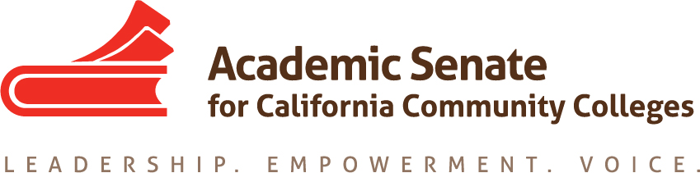

Educational Policies Committee

Friday, 4 December 2015

1:00 PM - 2:00 PM

CCC Confer - 888-450-4851

Participant Passcode: 458062

AGENDA

- Call to Order

- Approval of the Agenda

- Action/Discussion items

  - Current Business:
    - Plenary Debrief:
      - Dual Enrollment Breakout
        - Update on RP Toolkit
        - Document started by Wheeler
      - Board Policies Breakout
        - Notes from Tonya (thank you!)
        - Rostrum Article? Other information going forward?
    - IDI Breakouts (21-23 January in Riverside)
      - Academic Integrity
      - Civic Engagement (with Leg/CE task force)
    - Policy regarding items approved by Exec but not sent to the body
    - Update on resolutions
      - 7.01 and 15.01 (S15) -- Academic Integrity (IDI and Rostrum?)
      - 17.01 (F12): Grant Driven Projects: survey information at https://www.surveymonkey.com/results/SM-5ZZMBPNC/
      - 13.02 (F11): Supplemental Instruction Survey – in progress
  - New Business:

  - Spring 2016 Plenary
    - Ideas for Breakout Sessions (due 19 January)
      - Grants Driven Projects: Survey results and information?
      - Others?
    - Ideas for Resolutions

  - Upcoming Events:
    - Accreditation Institute, 19-20 February, Mission Valley Marriott, San Diego
    - Academic Academy, 17-19 March, Sheraton Sacramento
    - Area Meetings, Friday, 1 April (Areas A and B) and Saturday, 2 April (Areas C and D), locations vary
    - Online Education Regional Meetings – Friday, 8 April, College of San Mateo and Saturday, 9 April TBD (South)
    - ASCCC Spring Plenary Session, 21-23 April, Sacramento Convention Center

- Adjournment

