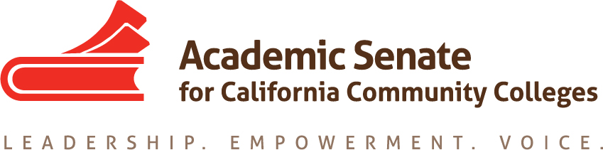

EDUCATIONAL POLICIES COMMITTEE

Thursday, 17 September 2015

9:00Am – 10:30 AM

CCC Confer (CCCConfer.org)
Participant Passcode: 306393
*Toll free number: 1-888-450-4821

AGENDA

- Call to Order

- Introductions and Note Taker

- Approval of the Agenda

- Discussion items, with action as needed
  - Priorities for 2015-16
    - Set calendar for remaining meetings
    - Dual Enrollment Document (13.02, F14): Resolved, that the Academic Senate for California Community Colleges compile and communicate guidance which identifies pertinent regulations and effective practices and clarifies terminology regarding the enrollment of high school students in college courses and publish this guidance by the end of Fall 2015.
  - Review of status of assigned resolutions –updated from August Executive Committee meeting
    - 7.01 and 15.01 (S15): Academic Dishonesty
    - 17.01 (F12): Approval of Grant Driven Projects
    - 13.02 (F11): Supplemental Instruction Survey and Glossary
    - 17.04 (S09): resources for Senate/Bargaining Unit Relations
  - Review of survey results on automatic awarding of degrees (Resolution 13.02 F12 now assigned)
  - Other?
    - Breakouts
    - Resolutions
    - Rostrum Articles

- Events:
  - Executive Committee – September 11-12, Sacramento City College/Citizen Hotel
  - Executive Committee – October 2-3, Mira Costa College/Hilton Resort and Spa
  - Executive Committee – November 4, Marriott Irvine
  - Fall CTE Regionals – October 9, American River College
October 10, Irvine Valley College
October 16, Bay Area-TBD
October 17, Modesto College

  - *Area Meetings – October 23, North
October 24, South
  - *Fall Plenary – November 5-7, Marriott Irvine
  - Curriculum Regional (North) – November 13, TBD
  - Curriculum Regional (South) – November 14, Mt. San Antonio College
  - Instructional Design and Innovation – January 21-23, Riverside Convention Center

- Other?
- Adjournment

