**The Seven Principles for Good Practice in Undergraduate Education**

**Good Practice encourages:**

* + 1. student-faculty contact
    2. cooperation among students
    3. active learning
    4. prompt feedback
    5. time on task
    6. high expectations
    7. respect for diverse talents and ways of learning.

Chickering and Gamson (1987) The **Seven Principles** for **Good Practice in Undergraduate Education** <https://files.eric.ed.gov/fulltext/ED282491.pdf>

**Plickers: Immediate Classroom Response System on the Cheap**

Each student receives a uniquely shaped card for answering. A question is displayed and students turn the card so their answer is facing up. The faculty scans the student responses with an iPad or phone and the students who have responded are indicated by turning blue. The response system analyzes responses to provide immediate feedback and discussion.

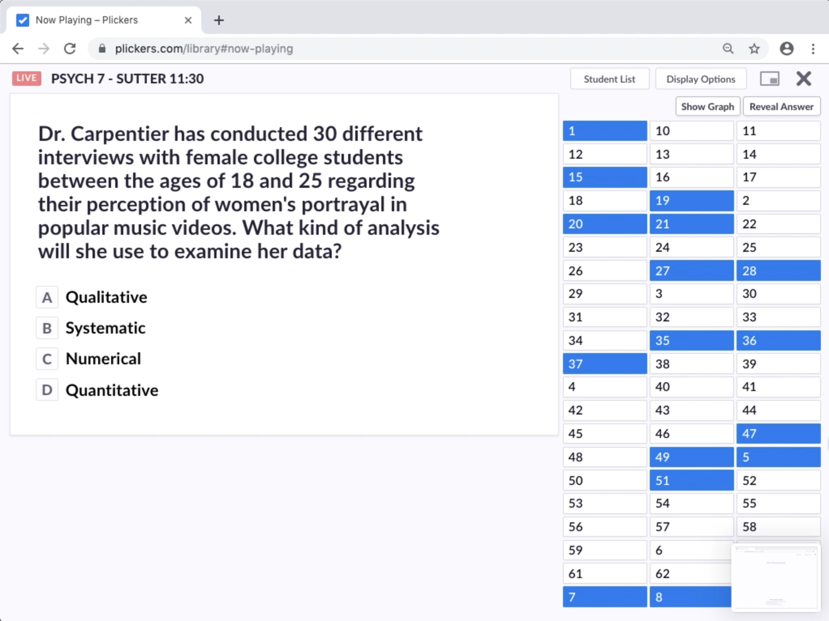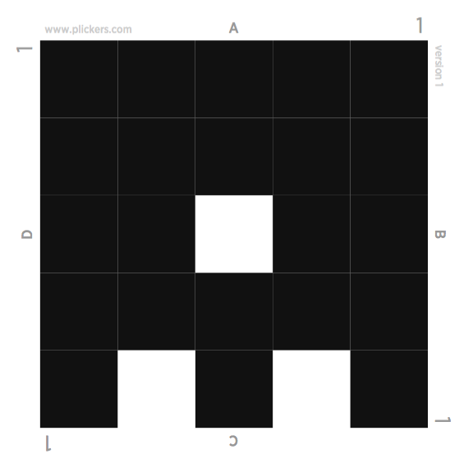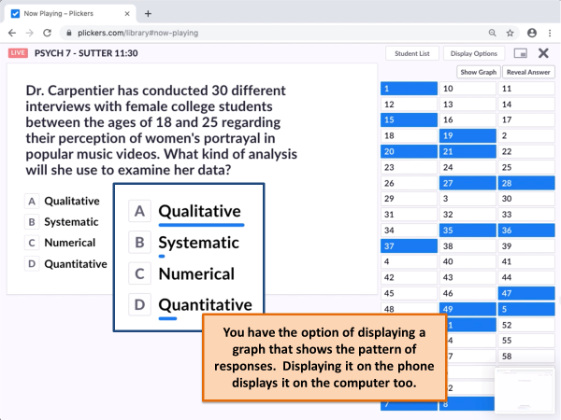



*The Learning Pyramid. The learning pyramid originally came from the National Training Laboratories (NTL) for Applied Behavioral Science, Alexander, VA 22314, US*

*It is no longer and student available. What do we know about learning retention?*

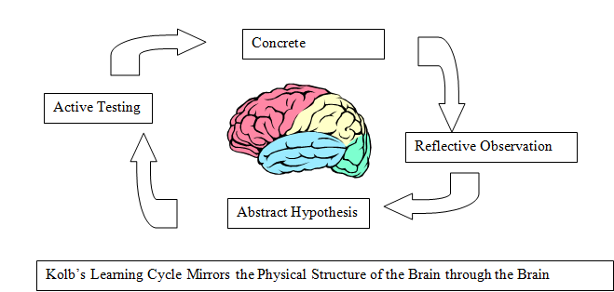

*The learning cycle involves four stages: concrete learning, reflective observation, abstract conceptualization and active experimentation. Effective learning can be seen when the learner progresses through the cycle.*

*Concrete learning - Encounter a new experience or reinterpret an existing experience.*

*Reflective observation - Reflect on the experience*

*Abstract conceptualization - Forms new ideas based on the reflections*

*Active experimentation - Applies new ideas to check for modifications in the next appearance of the experience (This becomes the concrete learning for the next cycle)*

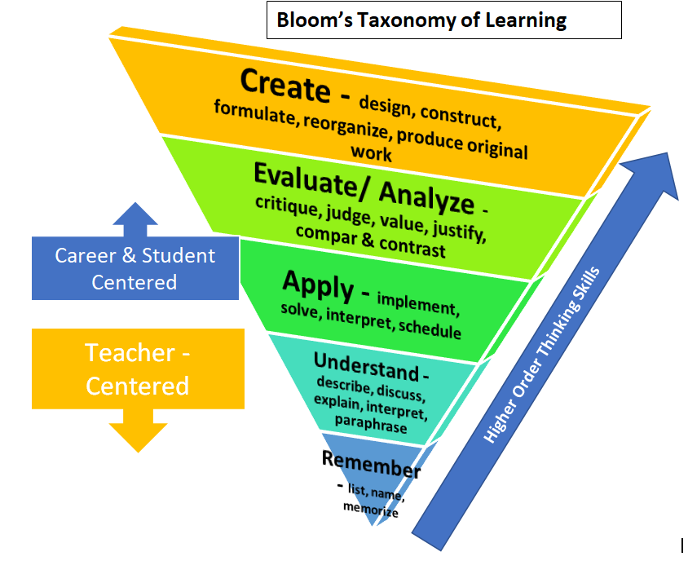

*Check out the CCSSE document posted “**A Mind at Work: Maximizing the Relationship between Mindset** **and Student Success** and 10 GREAT ACTIVITIES FOR EXPLORING INQUIRY-BASED LEARNING <https://cdn2.hubspot.net/hubfs/452492/10%20IBL%20activities%20Wabisabi%202019.pdf>