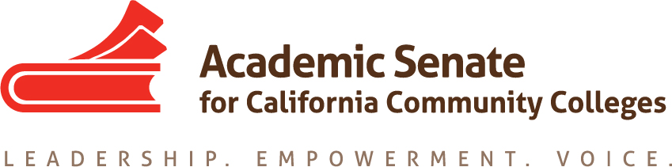

FACULTY DEVELOPMENT COMMITTEE

Wednesday, December 5, 2018

8:00-9:30 AM

ZOOM Meeting

All meeting documents are available in the Goggle folder.

https://drive.google.com/drive/folders/1GIHzQfQh0jiPQGZ8Jnc0Md545jODKudn

DRAFT SUMMARY

- Call to Order and Adoption of the Agenda

- Member Roll Call
Michele Bean Mayra Cruz
Carolyn Holcroft Rebecca Eikey present
Elizabeth Imhof LaTonya Parker present
Manjit(Manny) Kang

- Approval of 11/21 Meeting Minutes – by consensus

- Review Work Plan and Assignments
https://drive.google.com/drive/folders/1GIHzQfQh0jiPQGZ8Jnc0Md545jODKudn

Update on Status of Committee Priorities for 18-19 was provided.

https://docs.google.com/spreadsheets/d/16LxdTXnuPX8WUI8n0yPuQZSCARSDD72TTEk5g4xZLR8/edit#gid=296631368

a. Rostrum articles discussion and update
1. Information to local senate leaders regarding faculty professional development and its role at their colleges; rights and responsibilities for involvement in the development of faculty professional development policies, including the use of potential funding provided by AB 2558 (Williams, 2014) (Lead: Carolyn Holcroft will draft an outline of the article to include role of academic senate and use of funds.)
The committee discussed a draft of the article. There is background information about professional development as defined in AB 1725. Discussion of Effective Practices as it relates to Senate purview vs the institution. The idea of advocacy for PD funds was discussed. The article could end with a call to action. Carolyn will lead creation of the draft and sent by December 11th . Then committee members will contribute to the Google document. The article must be ready by January 7th.

- Assert to statewide initiative leaders the importance of respecting the purview of the Academic Senate and local senates regarding faculty professional development; California Community Colleges work with the Chancellor’s Office and other system partners to ensure that the Board of Governors’ Standing Orders are respected and that all future assignments in the area of faculty professional development involve input and affirmation from the Academic Senate and local senates.

The Committee discussed the importance of articulating the importance of faculty voice. There was a resolution passed at Fall Plenary that indicated the body’s dissatisfaction with the Chancellor’s Office leadership. The committee will wait to see how the Fall Plenary Resolutions are assigned to determine next steps with the development of the article. The committee discussed it would be important to be positive and articulate the improvements with the increased collaborations between ASCCC and Chancellor’s Office.

- Status of Previous Action Items
The committee discussed the Rostrum article development, see above. The Women’s Leadership Circle development has been delayed so the committee can focus on the Hiring Regionals and Hiring Summit.

- Faculty Diversification: ASCCC Spring 2019 Hiring Regionals and CCC/IEPI Building Diversity Summit
- Update on Regionals locations
Butte College will not be one of the sites of the Regionals due to the Camp Fire.
Yuba College will be the new location.
Bakersfield College, Monday Feb 21, 2019
Yuba College, Thursday Feb 25, 2019
Norco College, Thursday Feb 28, 2019
- Review Hiring Regionals Program Outline (including presenters)
Mayra worked with Silvester Henderson to finalize the Program Outline after the joint meeting of the Committees (Faculty Development and EDAC). Highlights of the program were discussed. The committee chairs will be recommending 6 breakout sessions to provide more variety to participants. There will be 3 breakout sessions per block. There are two General Sessions. Mayra will follow up with Manny to see which breakout session (2, 3 or 5) he would like to be part of.
- CCC/IEPI Building Diversity Summit Breakouts submitted
The Committee reviewed the breakout sessions that were submitted to CCCCO for the Summit.
- Reflections on the November 29th Joint Planning Meeting with the EDAC
The Committee shared their reflections on the Joint meeting, indicating how productive the shared collaboration was.

VII. Announcements
- Upcoming Committee Meetings
January 22, 2019 8-9:30am
Faculty Development Committee Meeting
ZOOM
- Upcoming ASCCC Events
https://asccc.org/calendar/list/events
c) Application for Statewide Service
http://asccc.org/content/application-statewide-service

VIII. Committee Meeting Calendar
  - Feb & March 2019- TBA

IX. Adjournment
Happy Holidays!

Status of Previous Action Items

- In Progress (include details about pending items such as resolutions, papers, Rostrums, etc.)
- Rostrum article #1
- Rostrum Article #2
- Hiring Priority Criteria Survey
- Faculty Diversification Hiring Regionals and CCC/IEPI Building Diversity Summit planning
- Women’s Leadership Circle

B. Completed (include a list of those items that have been completed as a way to build the end of year report).
- 2019 Faculty Development Work Plan

The Faculty Development Committee creates resources to assist local academic senates to develop and implement policies that ensure faculty primacy in faculty professional development. The committee assess the Academic Senate’s professional development offerings and makes recommendations to the Executive Committee on policies and practices for faculty professional development at a statewide level and on the development of new faculty professional development resources to ensure effectiveness and broader access and participation. Through the Professional Development College, the committee supports local faculty development and provides guidance to enhance faculty participation in the areas of faculty development policies, community college faculty professionalism, innovations in teaching and learning, and other topics related to academic and professional matters. The committee advocates for the importance of faculty development activities related to student success, quality faculty teaching and learning, academic and professional matters, and for appropriate levels of funding for such activities. https://www.asccc.org/directory/faculty-development-committee-1

