Faculty Leadership (Resolutions)
Saturday, June 18, 2022

Are you ready to learn how debate and voting works during plenary sessions or are you ready to refine your skills? Here are a few important things to know for this Saturday’s Faculty Leadership Institute session.

Important Reminders

- All mock resolutions must be submitted electronically through the online form by Thursday, June 16th at 6:00pm and the signature page can be found at https://tinyurl.com/ASCCCResolutions
- The deadline for pulling resolutions from consent is 9:50pm.
- Debate and voting begins Saturday, June 18th at 9:45am via Zoom.
- We will be using Poll Everywhere app to conduct voting. See below for more information about the software.
- The direct link for voting in Poll Everywhere is: https://pollev.com/ascccresolutions233

Using Chat During the Debate Sessions and How to Participate
Which Chat is the Right Chat?
We will use Zoom to conduct our debates; however, please be advised that the Zoom chat is reserved only for making parliamentary motions, parliamentary inquiries, and “lining up” at the parliamentary mic.
The Pathable chat is available for cheers; however, be advised that the team will not be monitoring the Pathable chat for parliamentary motions, parliamentary inquiries, and “lining up” at the parliamentary mic. Please use the Zoom chat.
How Do I Participate?
During regular voting sessions, delegates are invited to participate in debate, make parliamentary motions, and make inquiries.
If you would like to make a motion or debate an item, please use the following format in the Zoom Chat:
PM, Your Name, Your College/District Name
CON, Your Name, Your College/District Name
PRO, Your Name, Your College/District Name

The Resolutions Committee Chair will monitor the Zoom chat and delegates will be called on in the order they appear in the Zoom chat.

About Poll Everywhere

For voting, the ASCCC uses the Poll Everywhere app. Poll Everywhere can be accessed by either a mobile app on your smart device or via web browser on your desktop computer. We recommend that you do not login both on the mobile app and desktop computer app at the same time. Your app may timeout and you may miss the opportunity to vote.

Poll Everywhere is well supported by Chrome, FireFox, SafariOS, and Windows Explorer.

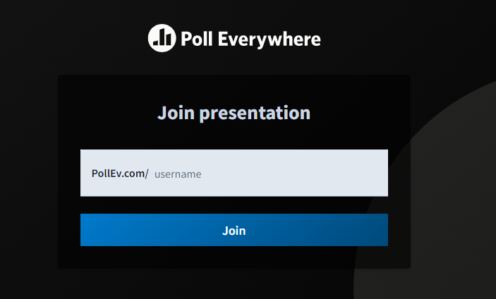
Preparing to Vote on Poll Everywhere
Figure 3. Screen to access ASCCC's presentation

Joining ASCCC Resolution Voting
- Navigate to Poll Everywhere’s home page at: https://pollev.com/home (Figure 3).
- Enter in “ascccresolutions233” and click “Join”
- Alternative, you can join by using the direct link: https://pollev.com/ascccresolutions233.
- Once you’ve joined the room, you will insert your name for the voting and click “Continue” (Figure 4).

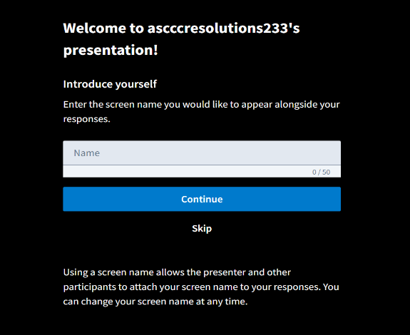
Figure 4
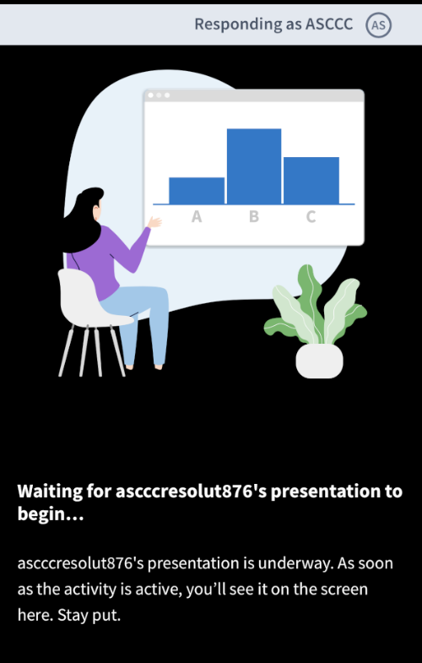
Figure 5

Resolution Voting
Once you have successfully logged in, you will see a screen that states “Waiting for ascccresolutions233’s presentation to begin” (Figure 5). If voting is live and you do not see the poll, please refresh your screen.

Congratulations! You are now ready to vote!

What If I am Experiencing Technical Difficulties?
No problem! We’re here to help. Please send an email to eventtechsupport@asccc.org. Although this email will be actively monitored, your patience is extremely appreciated.

