CSU General Education Area | Courses | Units | UC Intersegmental General Education Transfer Curriculum  IGETC | Courses | Units | 21st century skills
A.1 Oral Communication | 1 | 3 |  |  |  | - Collaboration and teamwork  - Creativity and imagination  - Critical thinking  - Problem solving  - Flexibility and adaptability  - Global and cultural awareness  - Information literacy  - Leadership  - Civic literacy and citizenship  - Oral and written communication skills  - Social responsibility and ethics  - Technology literacy  - Initiative
A.2 Composition Written Communication | 1 | 3 | 1. English Communication  One course in English composition and one course in critical thinking/English composition | 2 | 6
A.3 Critical Thinking | 1 | 3
B1 Physical Science  B2 Life Science  B3 Lab | 1  1  1 | 3  3  1 | 5. Physical and Biological Sciences  One physical science course and one biological science or course, at least one of which includes a laboratory | 2 | 7-9
B.4 Mathematics & Quantitative Reasoning | 1 | 3 | 2. Mathematical Concepts and Quantitative Reasoning | 1 | 3
AREA C: Arts, Literature, Philosophy, and Foreign Language | 3 | 9 | 3. Arts and Humanities  Three courses with at least one from the arts and one from the humanities | 3 | 9
AREA D: Social Sciences | 3 | 9 | 4. Social and Behavioral Sciences  Three courses from at least two disciplines, or an interdisciplinary sequence | 3
AREA E: Lifelong Learning and Self-Development |  | 3
American Institutions  From Areas already specified | 2 | 6 | 6. Language Other than English *  Proficiency equivalent to two years of high school courses in the same language. | Proficiency | Proficiency
Total |  | 38 | Total | 11 | 34
CSU Golden Four
How do you begin discussions about GE at your college?

Who belongs in these discussions?

What might be some useful guidelines going into this work?

CSU Transfer ADT
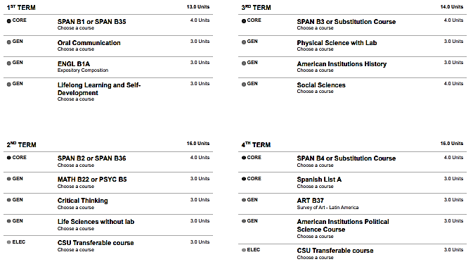
CSU Bakersfield
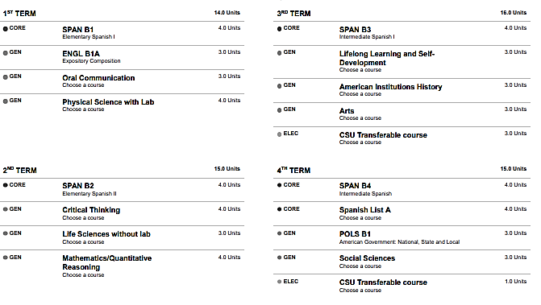
UC Transfer
