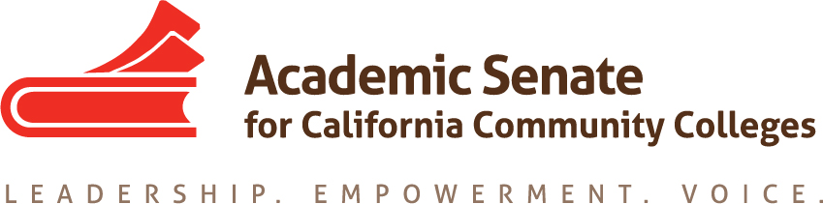

Legislative and Advocacy Committee

19 August 2019, 1-2pm

Join from PC, Mac, Linux, iOS or Android: https://cccconfer.zoom.us/j/130979738

Or iPhone one-tap (US Toll): +16699006833,130979738# or +16468769923,130979738#

Or Telephone:

+1 669 900 6833 (US Toll)

+1 646 876 9923 (US Toll)

Meeting ID: 130 979 738

MINUTES

- Call to Order and Adoption of the Agenda—meeting was called to order at 1:03 pm. Notes taken by Ginni May.
Present: Dolores Davison, Ginni May, Erik Reese, Kelly Kulzer-Reyes, Robert Stewart
Absent: none

- Introductions – Everyone introduced themselves. There will be an additional member appointed, hopefully in the next week.

- Charge of Committee: The Legislative and Advocacy Committee is responsible for providing the President with background information on all legislation related to academic and professional matters. Through research and analysis, and representation on appropriate advocacy groups, the Committee will provide the President and the Executive Committee with recommendations on such legislation. The Committee is also responsible for providing legislative alerts to the local senates, identifying liaison persons to contact legislators, and providing support to local senates regarding California's legislative process as it has bearing on academic and professional matters. It is the goal of the Committee to provide the President and the Executive Committee with the resources to ensure that the Senate is recognized as the voice of authority with the Legislature and Governor's Office in the areas of academic and professional matters.

Dolores Davison explained the role and history of the committee.
There is a letter ready to send to the Legislative Liaisons for each local academic senate to go out next week.

- Status of Previous Action Items
  - Assigned Resolutions (all completed in spring) – Davison provided background and an overview of the letters that were sent, along with some information on how the Chancellor’s Office considers legislation from various constituencies. She provided an example of the Universal Library System that was supported by the ASCCC.
    - AB302 was very much supported by the students. The CCLC opposed AB302 due to the possibility of economic implications to the colleges.
    - Other bills supported or opposed by the ASCCC are described in the legislative report. Davison provided an overview on: SB291, SB3, AB130, SB462, Funding Formula Letter, Online College Letter. Should have a good idea of the new laws by October 13. Last year, there were about 2400 bills by the end of February. About 40 to 50 had some implication on academic and professional matters.
  - Assigned Tasks – Legislative Advocacy Day
    - Date in late February/early March – A date has not been selected yet, as the chair needs to work with the president and the executive director to find out their needs. It would most likely be a Tuesday or Wednesday. There was a request from one committee member that it not be the 2nd or 4th Tuesday. It will not be the week of March 9 because that is the FACCC conference as well as the ICAS Legislative Day. Davison and Stanskas will be in Washington DC with the League, probably the week of February 17th.
    - Monthly Legislation Report (attached) and Budget Update for remaining 19-20 cycle
    - Goals

- Plenary Planning – 7-9 November in Newport Beach
  - Breakouts on Update on Legislation and the Budget/Baccalaureate Update – Davison submitted breakouts on Legislation and the Baccalaureate Program. May submitted one.
  - Resolution on Baccalaureate Pilot – this will come out for the fall plenary session. It may be Davison’s name, but could be a committee member’s name depending on the nature of the resolution.
  - Calbright (Online College) Clarification Letter (discussed above)
  - Other resolutions or breakouts? Davison invited emails or suggestions on resolutions.
- Announcements
  - Schedule for future meetings – no in-person meeting for fall is needed usually, but it depends on when the legislative visit is schedule. Davison will send out a Doodle Poll to schedule ConferZoom calls.

- Adjournment – 2:00 pm

Upcoming Events

- ESL Coding Project Regional Meetings
  - 5 September, Clovis Herndon Center
  - 11 September, Cypress College
  - 23 September, Skyline College
- Executive Committee Meeting, 6-7 September, Cerro Coso College
- Academic Academy: 12 – 14 September, Long Beach
- Executive Committee Meeting, 27-28 September, Riverside
- Area Meetings, 11-12 October
  - Area A, Woodland College
  - Area B, Solano College
  - Area C, Rio Hondo College
  - Area D, San Diego Mesa College

