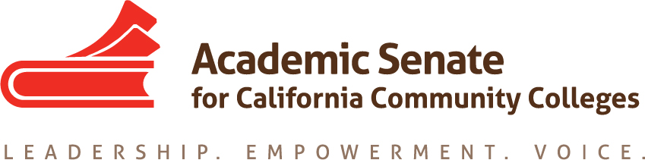

ASCCC Legislative and Advocacy Committee

Minutes

September 21, 2017

4:30PM-5:30PM

CCC Call Confer

888-450-4821

Participant Passcode: 853496

Presenter Passcode: 9287170

Membership:
Julie Adams, Executive Director ASCCC julie@asccc.org
Wendy Brill-Wynkoop, College of the Canyons brillwynkoop@gmail.com
Steve Cirrone, Sacramento City College steve.cirrone@scc.losrios.edu
Dolores Davison, ASCCC Secretary davisondolores@fhda.edu
John Freitas, Treasurer ASCCC freitaje@lacitycollege.edu
LaTonya Parker, At-Large Representative ASCCC latonya.parker@mvc.edu
John Stanskas, Vice President ASCCC, Chair jstanskas@valleycollege.edu

Charge:
The Legislative and Advocacy Committee is responsible for providing the President with background information on all legislation related to academic and professional matters. Through research and analysis, and representation on appropriate advocacy groups, the Committee will provide the President and the Executive Committee with recommendations on such legislation. The Committee is also responsible for providing legislative alerts to the local senates, identifying liaison persons to contact legislators, and providing support to local senates regarding California's legislative process as it has bearing on academic and professional matters. It is the goal of the Committee to provide the President and the Executive Committee with the resources to ensure that the Senate is recognized as the voice of authority with the Legislature and Governor's Office in the areas of academic and professional matters.

Members Present: Wendy Brill-Wynkoop, Steve Cirrone, Dolores Davison, John Freitas, John Stanskas
Members Absent: Julie Adams, LaTonya Parker

- Important Dates and Events
  - Plenary Session Breakout November 2-4, Irvine
Description for Legislative Breakout
  - In Person Committee Meeting – January
  - Spring Plenary April 12-14, San Mateo
  - ASCCC Legislative Action Day, Spring, Sacramento
Potentially Wednesday May 9 or Tuesday May 15, 2018

- Looking forward:
  - ASCCC Legislative Agenda Items
Last Year’s List
Full-Time Faculty and Faculty Diversification
Audit Fee
Veteran’s Support Centers/Services
Funding for Mental Health Services
Permanent and Sustainable Funding for C-ID

Recommended Legislative Agenda for 2017-2018
Full-Time Faculty and Faculty Diversification
Audit Fee
Permanent and Sustainable Funding for C-ID
Dedicated Professional Development Money for ASCCC to convene faculty discipline meetings to improve
student success and completion
Wrap-Around Student Support (Mental Health, Increased Direct Aid for Food and Housing Insecurity)

The committee discussed how these goals align with the system budget change request and the Board of Governors Vision for Success goals.

  - Legislative Periodical Update
The committee does not recommend a periodical for the fall plenary

- Current Legislation Concerns
  - AB705
The ASCCC needs to provide direction to the field regarding implementation should the Governor sign

- Next Steps: Tasks & Future Agenda Items / Meeting dates?
Meeting the first week of October to determine title and structure for plenary breakout

- Adjourn 5:40pm

