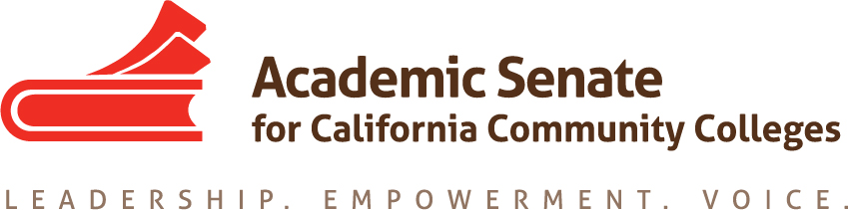

LEGISLATIVE AND ADVOCACY COMMITTEE

Monday, September 28 2015

10:30am – 12:00pm

MINUTES

- Call to Order – 10:00am
- Present: Julie Adams, Julie Bruno, Sam Foster, Kelsey Iino, Dolores Davison, David Morse, Stacey Searl-Chapin
- Scribe: Dolores Davison
- Approval of the Agenda –approved
- Orientation
  - Committee members discussed the charge of the Legislative and Advocacy Committee and its reinstatement last year. Information was provided about the Legislative update page including the Legislation Report provided to the ASCCC Executive Committee and new Legislative Liaison positions.
  - Additionally, a general orientation to serving on the committee was provided.
- Discussion items, with action as needed
  - Priorities for 2015-16
    - Set calendar for remaining meetings – Bruno will send out a Doodle poll to determine the next phone conference and one in-person meeting.
    - Legislative Agenda (Attachment: ASCCC Strategic Plan)
      - Morse provided context for the discussion including the vision of what the legislative agenda would be for the ASCCC. Committee members discussed possibilities. One suggestion was to determine the Academic Senate’s interest in current legislation (including 2 year bills) and pending legislation. Committee members discussed assisting other organizations that sponsor legislation.
      - It was noted that it is important to identify which issues are under the purview of the Academic Senate (10+1). Additionally it is important to identify what may be missing but to stay realistic in expectations. There are some issues that have been reoccurring that need to be dealt with (auditing fees; if AB 798 is not signed, will we need to seek legislation on OER?). Concern was expressed and it was determined that establishing criteria on legislative involvement would be necessary.
      - Committee members discussed the ASCCC role in writing legislation. As a nonprofit organization, it is unclear if the ASCCC can write legislation or only assist those who (CCCCO, FACCC, CCLC, etc). Adams will research and will report back.
      - There was an interest in advocacy as a whole: promoting what we do (both the ASCCC and faculty in the CCC system) to legislators and others so that they write legislation that makes sense for our system instead of trying to “fix” us.

  - Resolutions (Attachment: Committee Priorities)
    - Committee members discussed the resolutions assigned to the committee.
      - Resolution 20.01 S99 Loan Forgiveness was deemed “completed” by Bruno and Davison. Members discussed how to let faculty know the status of the resolutions (other than the website) and how to promote information (such as this loan forgiveness program) so that faculty are aware of it.
  - Review of status of assigned resolutions – discussed in item above
  - Plenary
    - Legislative and Advocacy Breakout –Vice Chancellor Vince Stewart has been invited to join us to discuss recent legislation that is of interest to the senate
    - Committee members Searl-Chapin, Davison and Foster will be attending plenary. Iino will try to attend.
  - Instructional Design and Innovation Institute (Attachment: Call for Proposals)
    - Committee members discussed the interest in submitting a breakout on Civic Engagement. Some members were concerned about low attendance (people choosing other breakouts over this one). Perhaps the topic could be embedded in other breakouts to encourage discussions and participation by faculty. A small workgroup (Julie Bruno, Stacey Searl-Chapin, Cynthia Reiss, Manual Baca and Patty Robinson) are discussing ways to expand interest in the topic; Julie Adams will join the meeting scheduled on October 12.
    - Committee members did not have other proposals for the IDII
  - Legislative Liaison Position (Attachment: CTE Liaison Example and Leg Liaison draft)
    - Committee members reviewed the draft document outlining expectations for local legislative liaisons. A suggestion to add to the document an expectation that the liaisons would work with student groups.
    - Discussion of a proposal to have LAC members act as points of contact for legislative liaisons within the four areas. As contacts the LAC members would provide a conduit between local colleges and the committee. Committee members will think on the proposal and revisit it at the next meeting.
    - Bruno will reach out to colleges that already have legislative liaisons in place including Modesto and De Anza to get feedback on the position expectations and bring it to the next meeting.
  - Resolutions for Plenary – Legislation resolutions are not anticipated at the fall plenary session since the Legislative session is complete. Resolutions will likely happen in spring.
  - Rostrum Articles due October 12, 2015 – Perhaps include an article on the legislative liaison position? Bruno and Davison will discuss and decide.
- Events - Committee members were informed of the following ASCCC events:
  - Executive Committee – October 2-3, Mira Costa College/Hilton Resort and Spa
  - Executive Committee – November 4, Marriott Irvine
  - Fall CTE Regionals – October 9, American River College
October 10, Irvine Valley College
October 16, Bay Area- College of Alameda
October 17, Modesto College
  - Area Meetings – October 23, North (Clovis, Evergreen Valley)
October 24, South (LA Mission, College of the Desert)
  - Fall Plenary – November 5-7, Marriott Irvine

  - Curriculum Regional (North) – November 13, Solano College
  - Curriculum Regional (South) – November 14, Mt. San Antonio College
  - Instructional Design and Innovation – January 21-23, Riverside Convention Center
- Other
  - Add to the next agenda a discussion on an ASCCC Advocacy Day
- Adjournment – 11:50am

