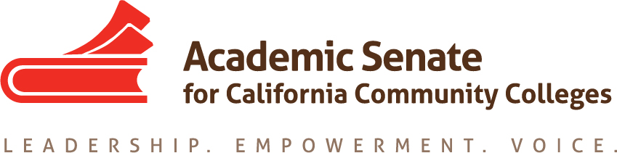

ONLINE EDUCATION COMMITTEE

Thursday, 25 February 2016

11:00 AM – 3:00 PM

Pierce College

CCC Confer – 888.450.4821

Passcode: 899634

AGENDA

- Call to Order

- Approval of the Agenda

- Discussion items, with action as needed
  - Report out on Instructional Design and Innovations Institute
  - Report out on Accreditation Institute breakout on DE and Accreditation
  - Plenary breakout on Hot Topics (probably with Accreditation)
  - OE Regionals (8 and 9 April)
    - Structure and breakouts/general session
      - 8:45-9:30 Registration and Continental Breakfast
      - 9:30 – 10:30 General Session – Updates
      - 10:30—10:45 Break
      - 10:45 – 11:45 General Session or Breakout #1
      - 12:00—12:40 Lunch
      - 12:45—1:45 Breakout #1 or 2 (2-3 breakouts)
      - 1:45 -- 2:45 Breakout #2 0r 3 (2-3 breakouts)
      - 2:45pm Dismissal

    - General Session Topics:
      - Updates from the OEI/CAI/Curriculum/ CCCCO?

    - Two or three breakout sessions?
        - Online Education and Accessibility
        - Regular and Effective Contact
        - Online Professional Development
        - Course Design and Online Instruction
        - Canvas Transition – Struggles and Successes
        - DE Addendum/Accreditation/Others – from the trenches
        - Cool4Ed/OER
        - Equity and Online Education
        - Academic Advising for Online
        - Non-DE online resources - using DE tools for non-DE courses
        - Online student success and how to move this needle
        - Nontraditional online - labs, CTE, basic skills, noncredit, inmate education
    - Who will be participating?

  - Annual Report
    - The Online Education Committee has been actively engaged in assisting faculty in pedagogy and other issues surrounding online education. The OE committee participated in multiple breakouts at the Fall Plenary session as well as the Instructional Design and Innovations Institute, completed the last Rostrum article to complete resolution 11.01 (S12) regarding effective online education practices, and authored several resolutions regarding online education as an academic and professional matter. Most significantly, the OE committee will be hosting a pair on Online Education Regional meetings, to be held 8 and 9 April, to assist faculty and others in the issues that are currently facing colleges, including the Online Education Initiative, textbooks and Open Educational Resources, and curriculum for online courses.

  - Best of the Rostrum

- Announcements
a. Area Meetings, 1 (Areas A and B) and 2 April (Areas C and D)
b. Online Education, 8 April (College of San Mateo) and 9 April (Glendale)
c. Noncredit Regionals, 15 April (San Joaquin Delta) and 16 April (Mt. SAC)
d. Spring Plenary, 21-23 April (Sacramento)
e. CTE Leadership, 6-7 May (Anaheim)
f. Faculty Leadership, 9-11 June (Riverside)
g. Curriculum Institute, 7-9 July (Anaheim)

- Adjournment

