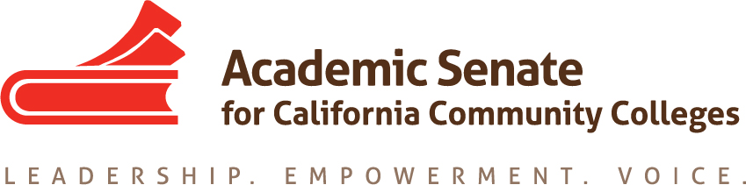

ONLINE EDUCATION COMMITTEE

Wednesday, August 26, 2015

10:00 AM – 3:00 PM

Glendale College, Administration Room AD121

1500 N. Verdugo Avenue, Glendale, CA

CCC Confer: 1-888-450-4821

Participant Passcode: 141703

http://www.cccconfer.org

AGENDA

- Call to Order

- Introductions and Note Taker

- Approval of the Agenda

- Set meeting times for remainder of year

- Priorities for 2015-16
  - Outstanding resolutions from last year
  - Role of ASCCC and Online Ed committee with PD organizations (@One, OEI, etc)
  - Curriculum Regional Participation
  - Online Education Regionals (spring?)
  - Innovations Institute Participation
  - Rostrum articles

- Plenary activities
  - Breakout topics
  - New Resolutions?
    - Accessibility
    - Faculty Primacy
    - Others

- Upcoming Events
  - ASCCC Area meetings October 23 and 24, locations vary. Contact your area representatives.
  - ASCCC Fall Plenary Session, November 5-7, Irvine Marriott Hotel.
  - Curriculum Regionals, November 13-14, locations TBD.

- Information from committee

- Adjournment

